Sacramento County 4H Horse Program
Silver Show Series
2017-2018

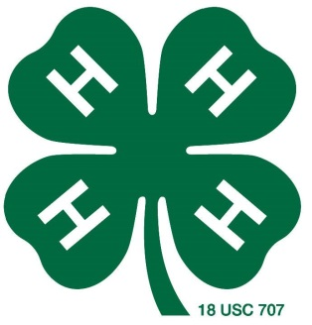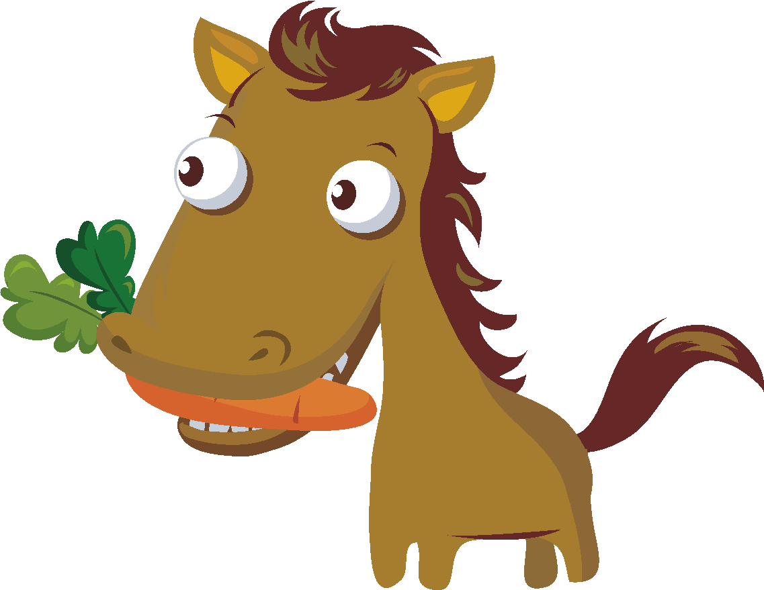
Show #1 February 24th, 2018
Triple Crown Equestrian Center
3243-3299 Gladding Road
Lincoln, CA 95648
*Classic Qualifier*
*Open to Out of County*

Check-in for the first classes will start at 7:15 A.M.
Classes will start promptly at 8:00 A.M.

PRE-ENTRY FEES*:
*Entries must be postmarked by: Friday, February 16, 2018.
$5.00 per class
$50.00 ride all day fee (one horse/one rider combination, does not include warm-up tickets or haul-in fee)
$10.00 haul-in fee payable to Triple Crown Equestrian Center (Separate check or cash)

POST-ENTRY FEES*:
*Entries postmarked or received after the pre-entry deadline or received the day of the show will be subject to the post-entry fee.
$30.00 Flat Fee per entry applies to all post-entries/entries day of the show

OTHER FEES:
$2.00 per warm-up ticket

- NO dogs please!
- Please refer to the Sacramento County 4-H Horse Program Rule Book for show rules.
- There will be a concession stand. All proceeds will go to Sacramento County 4H Horse Project!

Please review the rules and information contained within this Entry Premium Book, the Sacramento County 4-H Horse Program Rule Book, and the Silver Show Series Rules. All exhibitors, parents, and Leaders are responsible for reviewing any information pertaining to the 4-H Horse Program and the Silver Show Series and will be bound by those rules.

Questions? Please contact:
Sachorse4h@gmail.com

GENERAL SHOW RULES:
- Silver Show Series is open only to 4-H members in good standing.
- Each member must exhibit a bona fide project horse. The horse must be a bona fide project conducted solely by the youth exhibitor. If owned, the horse must have been owned and under the care and management of the 4-H member for at least 120 days prior to this show. If leased, the horse must have been leased and under the care and management of the 4-H member for at least 120 days prior to this show.
- Exhibitors are required to handle, care for, prepare for showing, and show their own animals. Parents and leaders may intervene only in cases where the safety of the child or animal is involved. If adults or non-4H members handle the horse for any other reason, it will result in the 4-H member’s disqualification. The exhibitor’s horse cannot be ridden at the event by anyone other than the exhibitor.
- Coaching during any classes is not permitted and may result in disqualification.
- There are no circumstances at any 4-H Horse activity where a horse should require excessive discipline, abuse, or punishment. If a horse does become so out of control so as to warrant such action it may be removed from the activity for the safety of all riders and horses. Abuse and punishment includes but is not limited to the following: excessive spurring or jerking of the reins; hitting the horse in front of the cinch, head, or shoulders; or any excessive whip lashes, whether mounted or dismounted at any time, anywhere on the show grounds.
- Patterns will be posted the morning of the show.
- Random working orders will determine the order of go in any pattern class with the exception of open card classes. Exhibitors will be responsible for exhibiting his/her animal in the established order of go. If an exhibitor misses his/her order of go, he/she may not be allowed to compete in the class
- There is NO SCHOOLING of horses in the lineup or during the class, whether or not the judge’s card has been turned in.
- Gate calls are a courtesy and will be enforced. Exhibitors are responsible for making sure that he/she makes it to his/her class on time.
- Classes will be considered closed once the gate is closed. No exceptions and/or late arrivals allowed.
- Warm-up classes are non-judged classes and are available and open for exhibitors to school their horses. Exhibitors must pre-purchase warm-up tickets in order to participate. Warm-up classes will only be open for a specified period of time and regular judged classes will have priority. If an exhibitor misses a warm-up class, he/she will not be able to participate regardless of if he/she has not used his/her warm-up ticket. However, warm-up tickets may be carried over to the next show.
  - Warm-up classes will be held on a ticket basis and tickets will not be designated for a specific warm-up class. ***Exhibitors will be responsible for making it to their warm-up class before that class closes.***
- Show management reserves the right to disqualify exhibitors and/or horses from competition for inhumane treatment, lameness/illness, unsafe practices, unsportsmanlike conduct, and refusal to follow show rules.
- Any inhumane treatment, unsportsmanlike conduct, unsafe practices will not be tolerated and exhibitors, parents, and/or 4-H leaders will be asked to leave the premises if such behavior is observed.
- Show management and/or judge’s discretion shall prevail.
- Refunds will be given only in the event that a signed veterinarian and/or doctor’s note is presented.
- Returned checks are not considered payment and are subject to a $100 returned check fee.
- Any protests must be:
  - Made in written form.
  - Include name(s) and phone number(s) of party or parties involved.
  - State the rule being violated.
  - Accompanied by a $50.00 deposit.
  - If the protest is deemed valid (protest sufficiently demonstrates that a rule has been violated), the $50.00 deposit will be refunded and appropriate action will be taken.
- All exhibitors, parents, and Leaders must follow all rules or the 4-H member will be disqualified and could be sent home. See 4-H Code of Conduct.
- NO DOGS ALLOWED ON THE SHOW GROUNDS (EXCEPT SEEING EYE DOGS).
- NO PARENTS, TRAINERS, OR OTHER NON 4-H MEMBERS ARE PERMITTED TO RIDE AND/OR HANDLE PROJECT HORSES ON THE SHOW GROUNDS.
- A 4-H member cannot receive professional help in any capacity at any time during the show or on the show grounds. This includes riding lessons.
- There will be no “Non-Comp” entries allowed. Every rider will be judged.
- Entry forms:
  - All exhibitors are responsible for ensuring that entry forms are sent in complete and correct. Incomplete/incorrect entry forms may not be processed and/or could result in delays at check-in. Show management is not responsible for ensuring entry completion and/or correction.
  - Signed medical forms must accompany every entry and be on file with the show office.
  - Entry forms must have all required signatures and necessary paperwork.
- Any classes held on an open card system will only be open for a specified period of time. It is the exhibitor’s responsibility to exhibit in his/her class before it is closed. Once the class is closed, no more exhibitors will be allowed to compete in the class.

Class Rules
- Classes with less than three entries may be combined or canceled at the discretion of the show management.
- Classes with more than 25 entries will be split and separate awards will be presented. *EXCEPTION – Classes for which there is a perpetual trophy will be worked in two parts with the finalists coming back to compete in a final class. One set of awards will be given.
- Class order is subject to change at any time and at the discretion of show management.
- Where noted on the class list, classes will be run concurrently.
- If a group (i.e., Jr., Sr., or Pony) is in one arena and is called in the other arena, show management will try to have the class wait. If the exhibitor is showing two animals (horse/pony/mini), the class will not be held. Exhibitor must choose.
- Ponies may be shown in Pony classes only except Showmanship, Vern Tanner Memorial (if eligible), and Versatility. Ponies must be under 14.2 hands and must be purebred or of mixed pony breeding.
- The 4-H member must show his/her own project horse.

Class Information
- Showmanship classes can be shown in either English or Western. However, equipment and attire must not be mixed.
- Hunt Seat Equitation classes will be English pattern classes and will be judged on the rider’s equitation.
- Mini and In Hand Challenge classes will be run as a Showmanship pattern class with knowledge questions contributing to part of the final score. Knowledge questions will be from the CHA Manual and/or the Level Testing Program Materials.
- Maiden classes are open to exhibitors who have not won a first place placing at any show in his/her respective Maiden class.
- Medal classes are advanced equitation classes with challenges for the exhibitors. Maneuvers are to be called out at the judge’s discretion.

Definitions
- MINI – Open to members showing a miniature horse with their regular horse project or with County’s mini project.
- IN-HAND – Open to member/horse or pony combo who is not at a level to ride in a show environment.
- NOVICE – Must meet the requirements as specified in the Sacramento County 4-H Horse Program Rule Book AND have the appropriate paperwork on file in order to compete in any Novice classes.
- GREEN HORSE – Must meet the requirements as specified in the Sacramento County 4-H Horse Program Rule Book AND have the appropriate paperwork on file in order to compete in any Green Horse classes.
- PONY – Must be less than 14.2 hands and must be purebred ponies or mixed pony breeds.
- JUNIOR – age 13 and under as of January 1, 2018.
- SENIOR – age 14 or over as of January 1, 2018.
- OVER FENCES DEFINITIONS OF JUMPING DIVISIONS: – Divisions are progressive with each progression dependent upon the successful completion of the previous division. Therefore, similar to the rules applied to the Novice Rider and Green Horse divisions, once a horse/rider combo has competed in a jumping division, they must continue to compete in the same or higher division.
  - Pony – under 14.2 Hands and must be purebred ponies or mixed pony breeds, 2’ – 2’3”
  - Short/Long Stirrup – (Beginners) 2’ – 2’3” - Indicated as a beginner class, no cross entry of jumping divisions. Rider able to complete a course at a canter. As they are still beginners, minor infractions judged accordingly.
  - Low Hunters – (Intermediate Class) 2’3” – 2’6” - Successfully completed Beginner Class division, or is capable of jumping an entire course at a canter without breaking gait, refusals, etc., and exhibit or possess a solid seat and leg in order to safely complete the course.
  - Children’s Hunters (Advanced Class) 2’9” – 3’ - Successfully completed Intermediate Class division, or is capable of jumping an entire course at a canter without breaking gait, refusals, etc. Exhibitor must possess a solid seat and leg in order to safely complete the course as well as knowledge and training techniques required for the advanced classes. The horse must be solid and experienced at jumping the indicated height, without refusals, etc.
  - Jumping Mini 34” & Under – horses must be 34” or under to compete, may not cross-enter classes
Jumping Mini Over 34” – horses must be over 34” to compete, may not cross-enter classes

Equipment and Attire:
- Boots and ASTM-SEI approved helmets are required in all classes. Helmets are required at all times when mounted and must be securely fastened.
- Horses must be shown in an approved Western bit (including snaffle or bosal hackamore) in all Western Performance classes. No mechanical hackamores, pencil bosals, tie-downs, martingales, or draw reins are allowed (except for Gymkhana/Fun events as noted below). Approved English bits must be used in English Performance classes. Running or standing martingales are not permitted in Hunter Hack or flat English classes but may be used in jumping classes. Boots and bandages are not permitted except in Stock Hose classes, Jumpers classes, and Gymkhana/Fun events. Equipment must be all Western or English, not mixed. Use of silver equipment and/or appointments is not to count over clean attire and tack in a good condition.
- Gymkhana/Fun Events: Any standard bit or hackamore (including mechanical) is permitted providing it is not considered severe by the judge or show management. Running or standing martingales and tie-downs are permitted. Draw reins are not permitted. Shin boots and bandages are permitted. All English or all Western tack and attire are required. Do not mix.
- Horses must remain in the same bridle/bit throughout a Riding Discipline. No changes allowed. Changes may be made when switching from one Riding Discipline to another (Western to English, Western to Gymkhana, etc.).
- See the Sacramento County 4-H Horse Program Rule Book for detailed descriptions on approved equipment and attire.

Awards Program
Ribbons first to tenth for Showmanship and Performance classes. High-Point Awards will be given based on cumulative scoring from the exhibitors best 3 out of 4 shows from the Silver Show Series and County Fair. See the Silver Series High Point Rules for more information. Only members of Sacramento County 4-H Horse Project are eligible to earn points in the Silver Show Series for all awards other than the Out of County Award.

Handy Show Tips

- Double check all tack and equipment  - Arrive early to lunge, park, check-in, and get ready  - Bring a pad and paper to draw and copy patterns  - Practice pieces of the patterns at every opportunity  - Keep a class list on hand at all times | • Carry a groom box to the arena  • Pre-dress as much as possible  • Do hair and make-up before leaving the house and not at the show  • Ask show savvy Senior members and Leaders for other tips!

Did you remember to…

- Verify that you have paid all of your Horse Materials Fees and are in Good Standing with the 4-H Office?
- Collect sponsorships?
- Double check that you are entered in the correct classes?
- Fill out your horse’s name and information as it is presented on your Registration Papers, Bill of Sale, Ownership Statement, and/or Lease Agreement?
- Obtain all the required signatures for your forms?
- Turn in the appropriate verification forms, if necessary?
- Include a check with your entry?
- Have your entry form and all required paperwork checked over and verified by your Project Leader for correctness and completion?
- Retain a copy of the entry rules and class list for your records?
We look forward to you participating in our Silver Show Series. Remember…it’s all about having a great ride, learning, and having a great time at the shows with your family and friends. It’s not about the placings…

Good luck and have fun!

CLASS LIST
(First classes will start at 8:00 AM promptly)
1  2  3  4  5  6  7  8  9  10  11  12  13  14  15  16  17  18  19  20  21  25  26  27  28  29  30  31  32  33  34  35  36  37  38  39  40  41  42  42  43  44  45  46 | Showmanship Senior  Showmanship Green  Showmanship Pony  Showmanship In-Hand  Showmanship Junior  Showmanship Novice  Showmanship Mini  In-Hand Challenge  Mini Challenge  Jumping Mini- All Heights  Hunter Under Saddle Novice  Hunter Under Saddle Green  Hunter Under Saddle Pony  Hunter Under Saddle Junior  Hunter Under Saddle Senior  English Equitation Novice  English Equitation Green  English Equitation Pony  English Equitation Junior  English Equitation Senior  Hunt Seat Equitation Novice  Hunt Seat Equitation Green  Hunt Seat Equitation Pony  Hunt Seat Equitation Junior  Hunt Seat Equitation Senior  Western Pleasure Novice  Western Pleasure Green  Western Pleasure Pony  Western Pleasure Junior  Western Pleasure Senior  Western Equitation Novice  Western Equitation Green  Western Equitation Pony  Western Equitation Junior  Western Equitation Senior  Western Horsemanship Novice  Western Horsemanship Green  Western Horsemanship Pony  Western Horsemanship Junior  Western Horsemanship Senior  Trail Novice  Trail Green  Trail Junior  Trail Senior | 47  48  49  50  51  52  53  54  55  56  57  57  58  59  60  61  62  63  64  65  66  67  68  69 | Trail Pony  Trail In-Hand  Trail Mini  Single Stake Mini  Single Stake Pony  Single Stake Junior  Single Stake Senior  Bi-Rangle Mini  Bi-Rangle Pony  Bi-Rangle Junior  Bi-Rangle Senior  Quad-Rangle Pony  Quad-Rangle Junior  Quad-Rangle Senior  CA Pole Bending (POLES I) Mini  CA Pole Bending (POLES I) Pony  CA Pole Bending (POLES I) Junior  CA Pole Bending (POLES I) Senior  CA Speed Barrels Pony  CA Speed Barrels Junior  CA Speed Barrels Senior  Cloverleaf Barrels Pony  Cloverleaf Barrels Junior  Cloverleaf Barrels Senior

Sacramento Co. Horse 4-H-2018 Silver Show #1
# assigned by office
one entry form per horse/exhibitor
hor
Mail entries to: Gina Simonsma 12491 La Vida Lane, Wilton CA 95693

NAME OF HORSE |  |  |  |  |  |  |  |  | YEAR FOALED |  | CIRCLE SEX
 |  |  |  |  |  |  |  |  |  |  | M |  | G
NAME OF EXHIBITOR |  |  | MAILING ADDRESS
CITY |  |  | COUNTY |  |  |  |  |  |  |  | ZIP CODE
EXHIBITOR PHONE # (xxx) xxx-xxxx |  |  |  |  | EXHIBITOR E-MAIL ADDRESS
4-H CLUB |  |  |  |  |  |  | 4-H LEADER’S NAME
EXHIBITOR INFORMATION |  | CLASSES ENTERED (enter class numbers in boxes)
Date of Birth
Year in 4H Horse
Pre-Entry Instructions |  |  |  |  |  |  |  |  |  | Pre-Entry Deadline
Entries must be hand delivered or post-marked by the deadline. Entries received or Post-Marked after the Pre-Entry date will be subject to the Post-Entry Fee. |  |  |  |  |  |  |  |  |  | February 16, 2018
Post-entries are subject to a $30 post-entry fee. Entries can be mailed or sign up the day of the show.

CALCULATING YOUR FEES  Place the number of classes (or All Day Fee) and warm-up tickets fees in the appropriate box(es) and multiply by the amount to get the total for each line item. If you wish to make a donation, please write the amount in the box. Apply the Post-Entry fee, if applicable. Sum all line items for your Total Amount Due.  Make checks payable to:  Sacramento County 4-H Horse | # of Classes |  | X $4.99 | =
 | All Day Fee |  | X $50.00 | =
 | # of Warm-Up Tickets |  | X $2.00 | =
 | Donation |  | Optional | =
 | POST-ENTRY FEE, if applicable |  | X $30.00 | =
 | TOTAL AMOUNT DUE

REQUIRED SIGNATURES. ENTRIES WILL NOT BE ACCEPTED WITHOUT APPROPRIATE SIGNATURES.
I do hereby consent that I have read all the rules pertaining to this event and agree to be bound by those rules.
x
Member signature / DATE
x
Parent Signature / DATE
x
Leader’s Signature / DATE

