A NOTE FROM THE COMMUNITY CLUB LEADER

Use this section to get important information to your club members, volunteers and parents. Examples are enrollment information, meeting information, club changes, etc.

Or change it up and have the club president write a note!

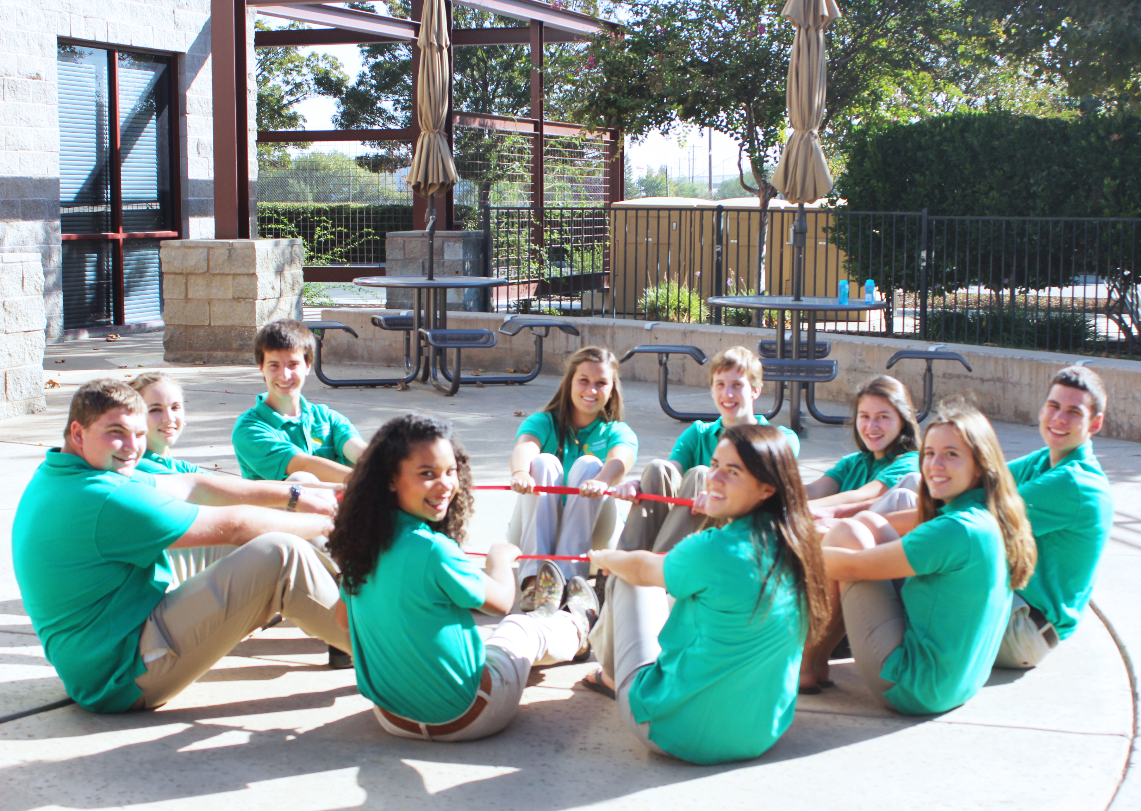
HIGHLIGHTS THIS MONTH

HEADER
Write a short description. Keep language brief and include links to more
information whenever possible. Images are a great way to keep a reader engaged.

Format this section to fit your county’s needs.
Tip: Edit space around your images by going to Format -> Wrap Text -> Edit Wrap Points

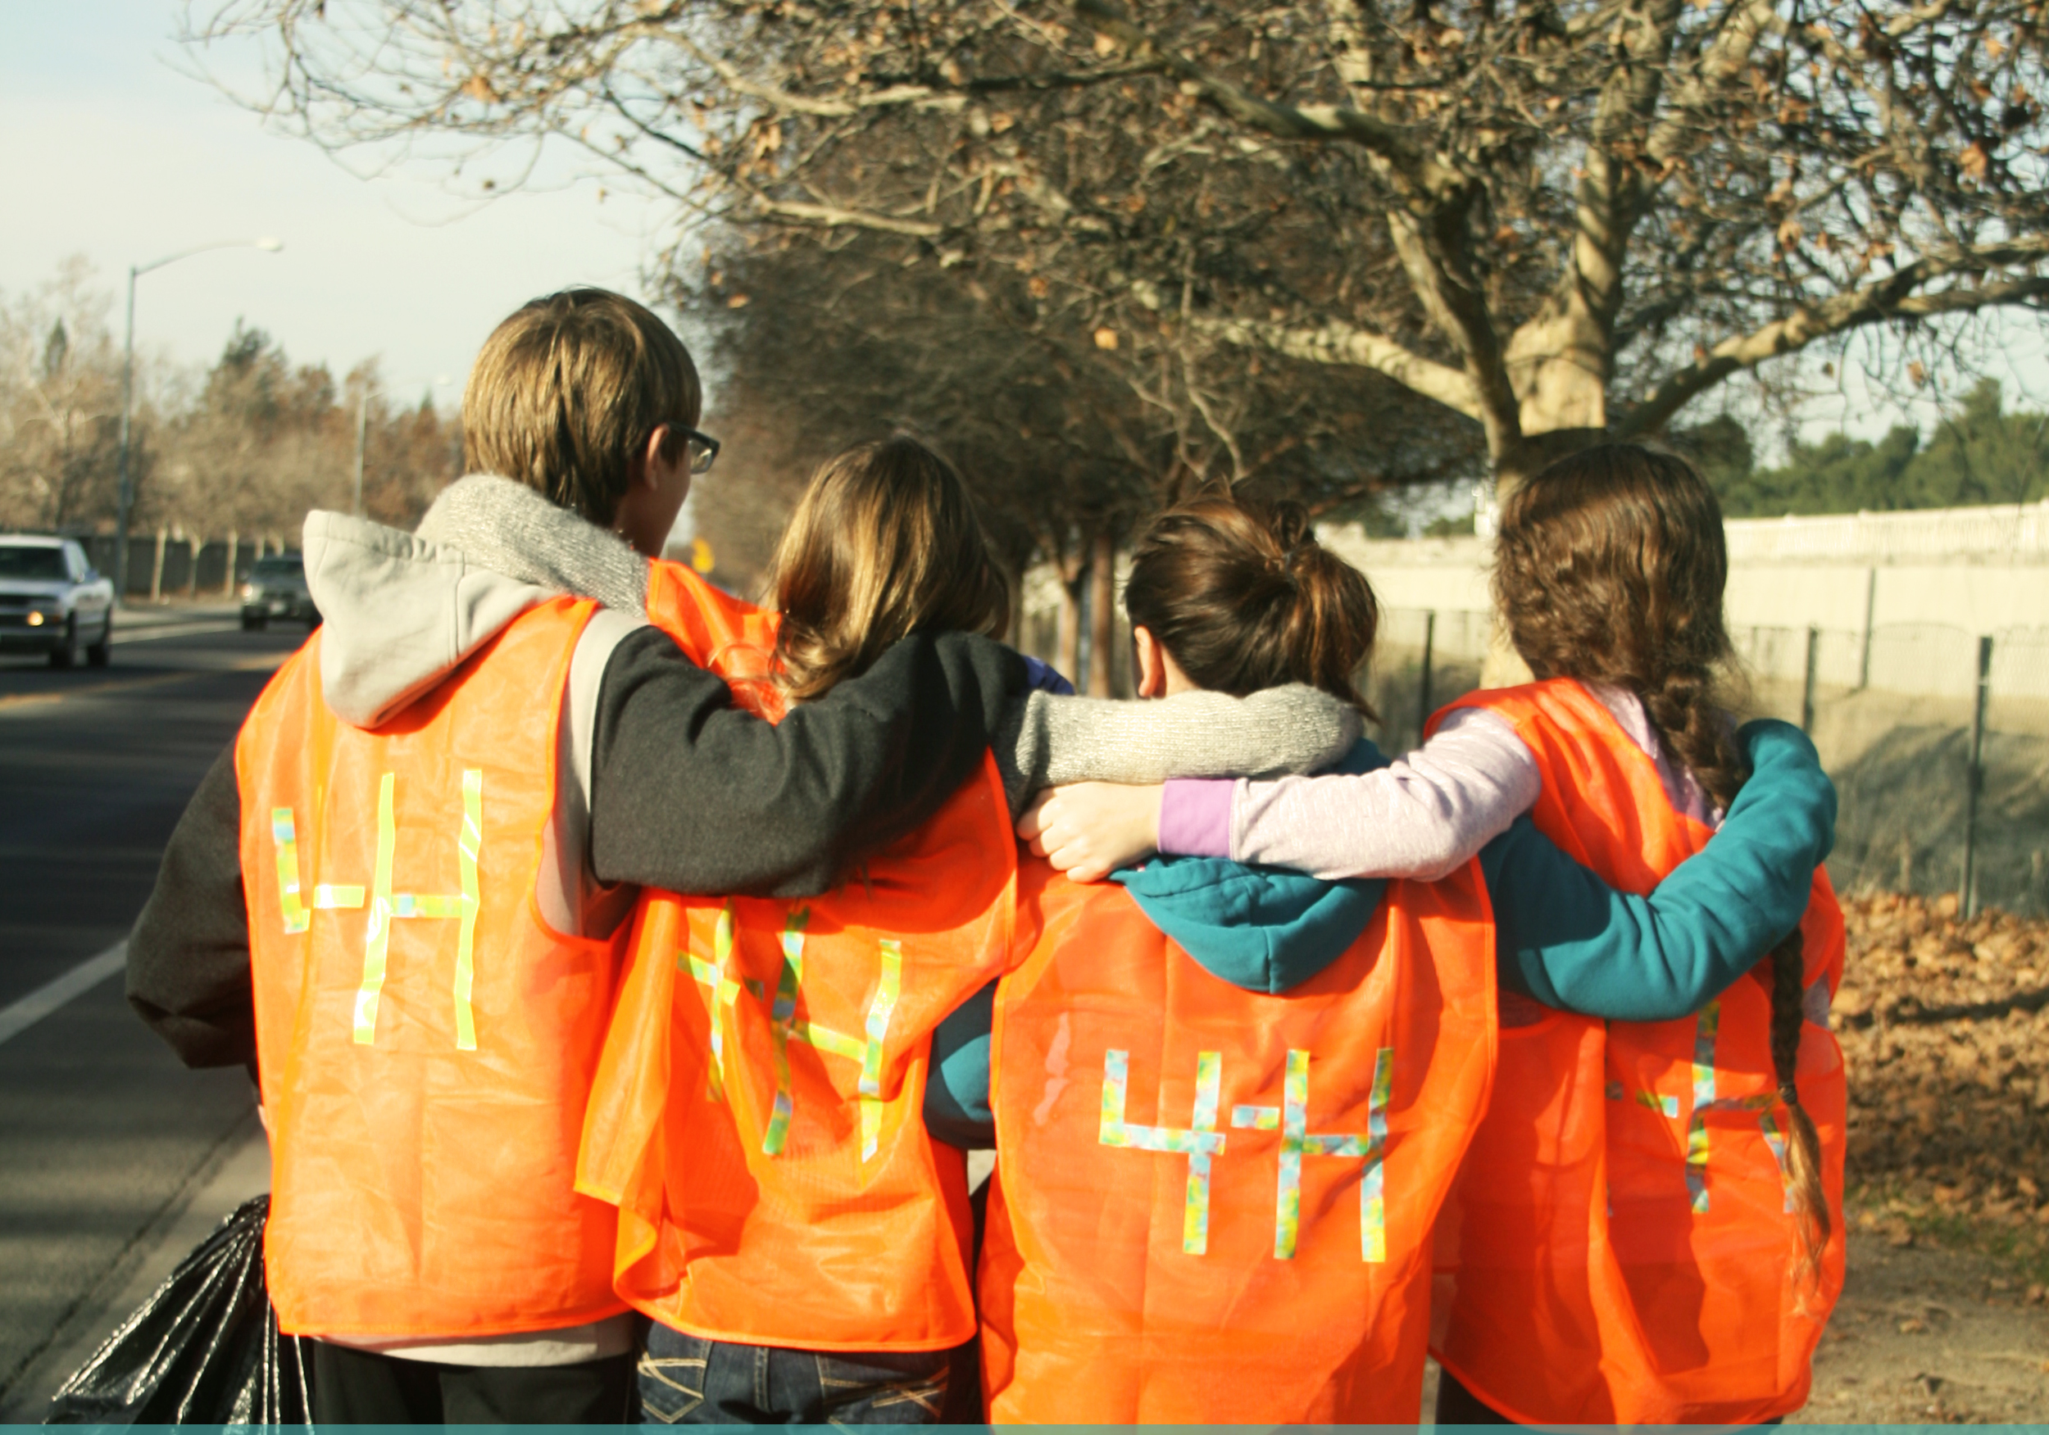
HEADER
Write a short description. Keep language brief and include links to more
information whenever possible. Images are a great way to keep a reader engaged.

Format this section to fit your county’s needs.
Tip: Edit space around your images by going to Format -> Wrap Text -> Edit Wrap Points

DECEMBER
MM/DD/YYYY Event title and link

JANUARY
MM/DD/YYYY Event title and link
FEBRUARY
MM/DD/YYYY Event title and link

MARCH
MM/DD/YYYY Event title and link

APRIL
MM/DD/YYYY Event title and link

MAY
MM/DD/YYYY Event title and link

JUNE
MM/DD/YYYY Event title and link

JULY
MM/DD/YYYY Event title and link
AUGUST
MM/DD/YYYY Event title and link

SEPTEMBER
MM/DD/YYYY Event title and link

OCTOBER
MM/DD/YYYY Event title and link

NOVEMBER
MM/DD/YYYY Event title and link

Member Tip of the Month:
Member Tip of the Month:
Create helpful tips and did you know facts for your
4-H volunteers. Examples are resources, trainings/professional development opportunities, tips and tricks to make their job easier, etc.
Volunteer Tip of the Month:
Create helpful tips and did you know facts for your
4-H members. Examples are resources, scholarships, leadership opportunities, project tips, etc.

CLUB
HEADER
Write a short description. Keep language brief and include links to more
information whenever possible. Images are a great way to keep a reader engaged.

Format this section to fit your county’s needs.
Tip: Edit space around your images by going to Format -> Wrap Text -> Edit Wrap Points

HEADER
Write a short description. Keep language brief and include links to more
information whenever possible. Images are a great way to keep a reader engaged.

Format this section to fit your county’s needs.
Tip: Edit space around your images by going to Format -> Wrap Text -> Edit Wrap Points
COUNTY/SECTIONAL
HEADER
Write a short description. Keep language brief and include links to more information whenever possible. Images are a great way to keep a reader engaged.

Format this section to fit your county’s needs.
Tip: Edit space around your images by going to Format -> Wrap Text -> Edit Wrap Points

HEADER
Write a short description. Keep language brief and include links to more
information whenever possible. Images are a great way to keep a reader engaged.

Format this section to fit your county’s needs.
Tip: Edit space around your images by going to Format -> Wrap Text -> Edit Wrap Points

STATE
HEADER
Write a short description. Keep language brief and include links to more information whenever possible. Images are a great way to keep a reader engaged.

Format this section to fit your county’s needs.
Tip: Edit space around your images by going to Format -> Wrap Text -> Edit Wrap Points

HEADER
Write a short description. Keep language brief and include links to more
information whenever possible. Images are a great way to keep a reader engaged.

Format this section to fit your county’s needs.
Tip: Edit space around your images by going to Format -> Wrap Text -> Edit Wrap Points
NATIONAL
HEADER
Write a short description. Keep language brief and include links to more
information whenever possible. Images are a great way to keep a reader engaged.

Format this section to fit your county’s needs.
Tip: Edit space around your images by going to Format -> Wrap Text -> Edit Wrap Points

HEADER
Write a short description. Keep language brief and include links to more
information whenever possible. Images are a great way to keep a reader engaged.

Format this section to fit your county’s needs.
Tip: Edit space around your images by going to Format -> Wrap Text -> Edit Wrap Points

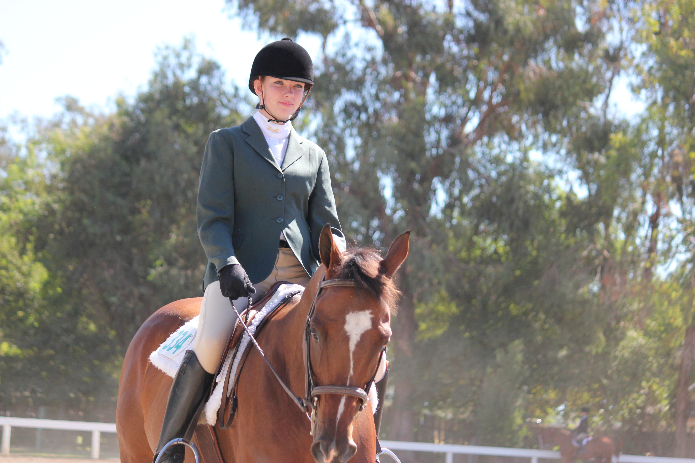
PROJECT CATEGORY (EX. EQUINE)
PROJECT HEADER
Write a short description of the project updates. Keep language brief and include links to more information whenever possible. Images are a great way to keep a reader engaged.
Format this section to fit your county’s needs.
Tip: Edit space around your images by going to Format -> Wrap Text -> Edit Wrap Points
PROJECT HEADER
Write a short description of the project updates. Keep language brief and include links to more information whenever possible. Images are a great way to keep a reader engaged.
Format this section to fit your county’s needs.
Tip: Edit space around your images by going to Format -> Wrap Text -> Edit Wrap Points
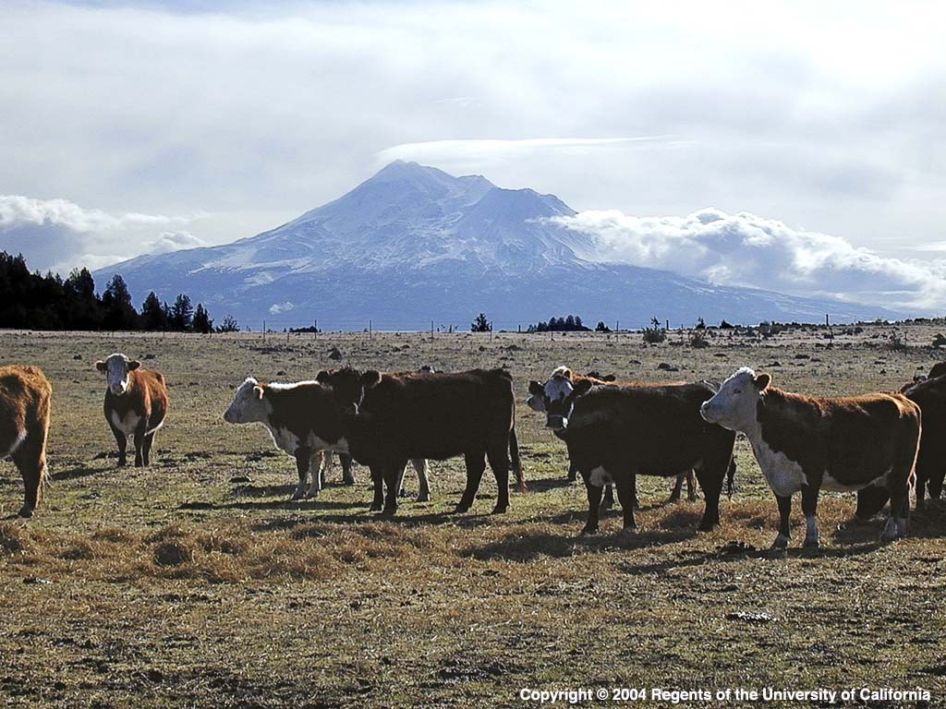
PROJECT HEADER
Write a short description of the project updates. Keep language brief and include links to more information whenever possible. Images are a great way to keep a reader engaged.
PROJECT CATEGORY (Ex. BEEF)
Format this section to fit your county’s needs.
Tip: Edit space around your images by going to Format -> Wrap Text -> Edit Wrap Points

PROJECT CATEGORY (Ex. PHOTOGRAPHY)
PROJECT HEADER
Write a short description of the project updates. Keep language brief and include links to more information whenever possible. Images are a great way to keep a reader engaged.
Format this section to fit your county’s needs.
Tip: Edit space around your images by going to Format -> Wrap Text -> Edit Wrap Points

