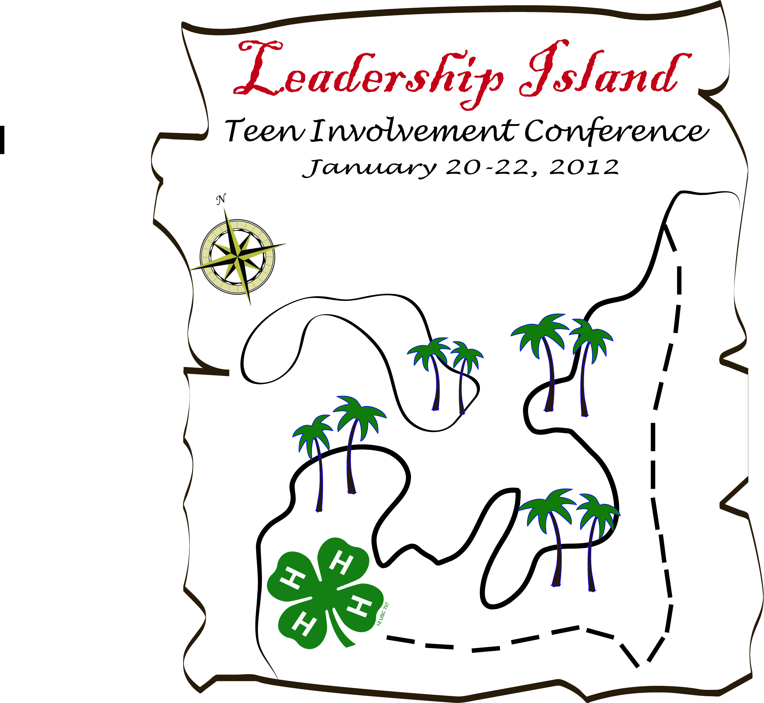
Youth Registration Form
21th Annual Teen Involvement Conference
January 17-19, 2014
fb.com/4HTIC

Registration Fee: Early Bird: Application postmarked by December 13, 2013
Registration Fee - $120.00
Normal: Application postmarked between December 14, 2013
and January 4, 2014: Registration Fee - $140.00
Late Registration: Bring to January South Section Council Meeting or in Person to Conference Check-in Application: Registration Fee - $160.00
No refunds of fees after January 10, 2014
Conference Information:

- The Teen Involvement Conference is open to all California State 4-H members aged 13-19 years old. Members must be 13 and not older than 19 by January 1, 2014.
- Ages must be verified by the local club leader with a signature located on this application form.
- All members must agree to the 4-H Code of Conduct and any rules set forth anytime during the conference by planning staff or chaperons.
- For every 8 youth attending, one Chaperon is required or the youth will not be able to attend.
- NO ONE CAN LEAVE EARLY FROM TIC WITHOUT PRIOR PERMISSION!!!
*TIC REGISTRATION IS ON A FIRST COME, FIRST SERVE BASIS,
SO GET YOUR APPLICATIONS IN AS SOON AS POSSIBLE.*
Chaperon Information:

- . If there are male youth attending the conference it is required that there is a male chaperon from the youth’s county.
- To be a chaperon at TIC you must be an enrolled 4-H leader and over the age of 21 or follow your county chaperone guidelines.

Applications are required to have the following: signed application, signed code of conduct, signed medical release form, signed dress code sheet, Pathfinder Ranch’s Release Form and registration fee in the form of a CHECK or MONEY ORDER made out to the South Section Leaders Council.

APPLICATIONS WILL NOT BE ACCEPTED WITHOUT FULL PAYMENT!

Mail in all required forms and payment to the address below:
Amanda Penicks
4019 Temescal Ave.
Norco, CA, 92860
PKSBackyardfarms@aol.com
Cell Phone after 4:00pm:(951) 520-3316

Youth TIC Application

Name:_____________________________________________________________ Age: ______________
Mailing Address: _______________________________________________________________________
City:_____________________________________________________ Zip Code:____________________
County:_________________________________________ Phone #: ______________________________
Email Address: _________________________________________________________________________
Member’s Signature:_____________________________________________________________________
Parent’s Signature:_______________________________________________________________________
Local Club Leader’s Signature:_____________________________________________________________
Phone #________________________________________________________________________________

Workshop Selection

Please select a first and second choice for each workshop. Every effort will be made to accommodate the first choice of each participant. Attendance to workshops is a conference requirement, and selection is on a first come first serve basis.

Workshop A 1st Choice__________ 2nd Choice____________

Workshop B 1st Choice__________ 2nd Choice____________

Workshop C 1st Choice__________ 2nd Choice____________

Workshop D 1st Choice__________ 2nd Choice____________

Please Attach, Completed: ~Code of Conduct
~Medical Release
        - youth for participants
~Pathfinder Ranch’s Release Form

This is a leadership conference. All the delegates will be expected to participate in the workshops and to attend all general workshops. During these workshops no one will be allowed to stay in their cabins. If the delegate becomes ill they will be staying with the nurse in the medical cabin.

Mail in all required forms and payment to the address below:
Amanda Penicks
4019 Temescal Ave.
Norco, CA, 92860
PKSBackyardfarms@aol.com
Cell Phone after 4:00pm:(951) 520-3316

Workshop Sessions

Session A  10:10 A.M. | Session B  1:40 P.M. | Session C  3:30 P.M. | Session D  8:30 A.M.
How to Interview | Photo Editing | Project Duct Tape | This is Your Brain!
Photography Beyond Auto Settings | Double the Size of Your Club | Strength In Numbers | Getting People Involved
Yoga  Get Used To It Or Get O.V.E.R. IT | There's No I in Team  Think Outside the Backpack: The Power of Goals | Team Building  How to create a Newsletter | I Like to Eat Apples and Bananas  Healthy Living
How to Interview
Devany Kelley, San Bernardino County
This session explains how to complete a resume and cover letter. It also shows how to dress properly and answer questions that can be asked.

Project Duct Tape
Lindley Mason & Gracie Morgan, San Diego County
Fun, team building session where teens work together to make a wearable garment out of duct tape and cloth. Teams must design the outfit, put it together, and model it.

Photography Beyond Auto Settings
John Trammell, CA 4-H Technology Leadership Team
Learn how to use the manual settings on a DSLR camera to give you total control over taking the perfect photograph. This is a perfect session for anyone who wants to improve their photography. You will learn f/stops, exposure settings, ISO, Depth of Field, camera mechanics, and much more. Even if you do not have a DSLR, you will learn a few settings that can be used on a point and shoot camera.

Photo Editing
John Trammell, CA 4-H Technology Leadership Team
Learn how to digitally edit your photographs with a free photo editing software called GIMP.

Double the Size of Your Club
Dee Keese & Rick Herbert
Want to increase the membership in your club. We can suggest ways to do just that. How we started with 17 members and now have 130. Come brainstorm with us.

How to create a Newsletter
Amanda Penicks, CA 4-H Technology Leadership Team
Adults and youth will learn how to create a newsletter using word that will catch the eyes of readers. Participants will be able to insert pictures, clipart, and various shapes. They can bring back their skills to their county and illustrate newsletters in the future.

There's No I in Team
Kelly Dowlan
Leadership is more than just the individual leader. Building your team, engaging and empowering those you are leading, is an essential element to successful leadership. A leader is only as strong as the team they lead!

Yoga
Ashleigh Mathias & Becky Bender, Orange County
Beginner yoga moves to help you relax and stay fit and healthy!

I Like to Eat Apples and Bananas
Ashleigh Mathias & Becky Bender, Orange County
Learn about how to make healthy choices when choosing food and exercising!

Get Used To It Or Get O.V.E.R. IT
AJ Adams
Whether it is failing grades, broken relationships or dropping out of school, every student deals with failure. And every student has the capacity for success if they only make the right choice in the midst of failure. AJ presents students with the choice to get used to it or get O.V.E.R. it – to Overcome failures Vertically and Endure Relentlessly beyond them.

Strength in Numbers
Emily Morris & Marcela Opie, Cal Poly SLO Engineering
Have you ever wondered what goes it takes for buildings to stand up? Even during an earthquake?!
This session will discuss some of the design aspects that are taken into account, followed by an activity to put those concepts to use.
Join us and see if you have what it takes to build the tallest tower!

Team Building
Cole Breck, Siena Rasmussen, and Tiffany Crane, Santa Barbra County
Learn how to strength your team (either it be all-star team, camp planning committee, county planning team, etc...) by learning team building exercises along with icebreakers games. We will show what it takes to have a successful team and how to overcome some of the obstacles that could get in the way.

Getting People Involved
Cole Breck, Genevieve Mason, and Derickson , 2013-2014 State Ambassadors
Learn how to get more youth and adults in your county to attend more events and increase participation throughout the section and state level.

Think Outside the Backpack: The Power of Goals
Joe Fingerhut
This is not a run-of-the-mill lecture. Students will gain a powerful perspective plus useful tools on goal-setting, interacting with the speaker and each other in addressing the most effective ways to set, remember, pursue, and most importantly, achieve, their goals as an individual and as a leader in an organization.

This is Your Brain!
Stephanie Barrett
Your brain performs an incredible number of tasks everyday. It controls your heart rate, breathing and body temperature at the same time you are walking, talking, or writing a paper. In fact, you will have about 70,000 thoughts today! In this workshop, we will learn how all of this information is sent. Then working in teams, we will build an electronic model to show how nerve impulses are transmitted through the human brain.

Healthy Living
Devany Kelley
Aworkshop on the healthy living initiative.

Items to Bring to Conference

Personal Items:

Sleeping Bag
Pillow
Towel
Washcloth
Toothbrush/paste
Soap/Shampoo
Warm Clothes (enough for 2 days)
Pajamas
Extra socks
Shoes (sandals/flip flops discouraged)
Jacket
Hat/Beanie (optional)
Mittens/Gloves/Scarf (optional)
Flash Light
Your Enthusiasm!!!!

Items to Share: (each delegate is asked to bring these items to share)
1 healthy Snack Item for the community snack table (may bring more if you wish)
Items for Community Service Project
Water bottles to share

County Participation: (each county is asked to bring these items to participate in the opening ceremonies)
Poster to showcase your county
At least one flat of water (more would be appreciated!)

To make this conference great we highly recommend that your county have a meeting with all of the delegates attending the conference to go over all of the forms and required items along with behavior, how treat the staff, county chaperones, and other delegates.

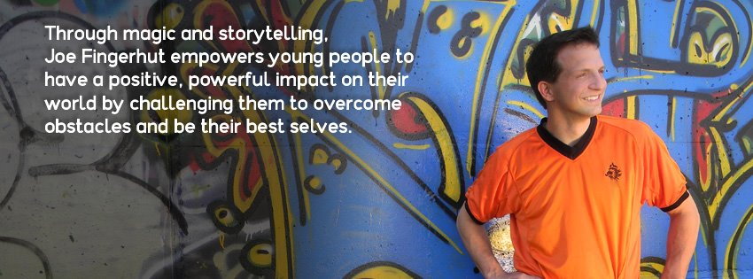

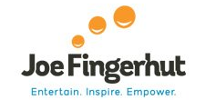

Meet Joe

Joe Fingerhut speaks from the heart about issues that are real to young people today. He has faced adversity, suffered loss, and pursued his passions despite long odds. Joe connects with audiences using humor, magic, and relevant stories of his own adventures, and he has a knack for connecting each young person’s heart with a powerful message of hope.
When he was 14, Joe’s best friend had his life taken in a car accident. Mark and Joe had been close since they met in kindergarten. A family member trying to comfort Joe said a phrase that has stuck with him to this day. She said: “Joe, think about all the things Mark won’t have to experience in life.” Even at such a young age Joe knew that this was the wrong attitude about living. Instead he thought about all the things he wanted to experience and thus started marching to the beat of his own drum. Mark’s death helped Joe begin focusing on the possibilities the world had to offer rather than the limitations. By the time he graduated college, Joe had been the school mascot, tried stand-up comedy, performed in theater, learned magic, and was a successful door-to-door salesman—all things that taught him he loved to meet people and entertain. A decade later, Joe had been to 30 countries on six continents and found a way to make a living by entertaining. His skills in magic, storytelling and performance have paved the way for a successful career as a speaker, teacher, and a music DJ. In fact, Joe was named the 2011 National DJ of the Year by Complete Music.
Joe focuses on conquering the “destiny of normalcy,” which afflicts too many young people today. He gives students a five-step method to achieving goals and communicates a positive message of turning “I can’t” into “How can I?” while sharing stories from his life, his travels, and showcasing his amazing skills in juggling, magic, and performing arts.
He is passionate about inspiring young people to dream bigger dreams, eliminate limits, and lead themselves, all the while teaching them the power of right choices, attitude, and character. He leaves them with tools to transform their lives and the world around them. He has spoken at schools, youth groups, camps, and conferences across America.

Joe envisions a world where people take action instead of placing blame, where possibility is more prominent than limits, where hunger for learning is greater than the fear of the unknown.

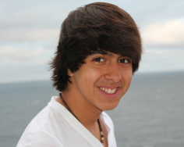

Name: Amit Dodani
Age: 14
State: California, USA
Education: Freshman, High School

My Biggest Weakness - My Biggest Strength

My name is Amit and I am a 14 year old boy from Los Angeles, California. I have gone to both middle school and now high school at a local school in the suburbs of Los Angeles, and am now a freshman in high school. I have grown up in a very positive environment, positive family, positive friends and just a positive attitude in general. My dad and mom own their own business and also speak at various events all across the country. I grew up with lots of opportunities to go out and get involved, from baseball lessons to tae kwan do, my parents always wanted me to go out there and find something that I love to do, find my passion. I sincerely wouldn’t replace my life for anything, don’t get me wrong, but here is my story…
From an early age, I had a little speaking problem. Well, my parents made it seem little (positive attitude) but essentially, if I tried to say the word “cat” it would come out as “tat,” if I tried to say the word “God” it would come out as “Dod” and if I tried to say the word “rex” it would come out as “res,” you get the whole idea. It was cute till i was about 3 or 4, but then it actually started to get serious. At around 6 or 7 years old my parents signed me up for speech lessons, with a therapist at one of the local schools nearby. I remember going through weeks of unproductive and quite agonizing lessons from this teacher who really didn’t know what to do about me. But nevertheless, the lessons must have helped a little bit, but it still never fixed the problem for me. Whenever I would meet a new person and say a phrase like “Tan I get you something?” I would get the same reaction, “what!?” Even in class, when someone would sneeze I would go “Dod Bless you,” the reaction would be “excuse me?” It never necessarily bothered me at first, but slowly it kind of got to my head a little bit. Of course I would have my close friends, who would tell other people about my whole speech issue and what not, but I sort of just tended to keep quiet about it. My parents kept telling me it has to get fixed, and even family members would always kind of give me that awkward look when I pronounced a word wrong.
Then came the time when I actually had to speak in PUBLIC. I remember the first time I went up to say a few words to my parents business partners after one of their meetings, I sat down for hours trying to write my speech (this was when I was in 5th grade) and I thought I had it all down. As soon as I began talking, I started jittering, and shaking, and then of course you could see some tears running down my eyes. Oh well needless to say, those 3 minutes lasted a long, long while for me. Furthermore, when I was in 6th grade my parents had just received this great recognition in San Jose, and one of their friends asked me to share a few words at the surprise party they were having at that time. Unwillingly, I walked onto the stage, stared at the 100 or so people that were in the audience and my mom and dad - next thing I know I started balling while running off back to my hotel room. They were shocked, I mean my dad was a public speaker, everyone thought it would be almost natural for me to be the same, but of course it wasn’t. The speaking problem and even the inability for me to speak in public were almost absurd for any of my friends or family to comprehend. The only person who did not think it was that bad, was myself. It was quite frustrating, having to explain to my friends why I couldn’t say words correctly, and seeing all my family help me with speaking. Yes, I was embarrassed, but I, for some reason had some feeling in my gut that it didn’t matter if I stumbled on my words, it didn’t matter if I couldn’t pronounce my c’s or k’s or q’s or z’s or g’s or x’s correctly, it didn’t matter that my hand or leg would shake uncontrollably whenever I was behind a podium. Ha, and I was only 10.


I kept on doing little 3 minute speeches, but every time those tears would still boil up in my eyes. Even in 7th grade I would have some people joke around about the way I pronounced some words, and yes I knew they were “just kidding,” but it was a little bit obnoxious at one point. The process continued on and on and on, and then at one point I had to prove that I was better than what it seemed. Towards the end of 7th grade, I had Mock Trial and Debate tryouts for my 8th grade year. I was a little iffy on whether or not I should do it, mostly because I just didn’t want to look bad in front of everyone, but after a long conversation with my parents I decided that I should do it. Little did I know, I just made the decision that would change my entire life for the better. I made it! Come 8th grade, my coaches said that it would be time to determine roles, meaning who is who in the trial. My one time being the defense attorney and delivering a 5 to 6 minute speech, staring right into the quite piercing eyes of my coach, my hand was shaking as I delivered the entire thing. By the end of it, I was totally shaken up to the point where my coach asked me if I was okay afterwards. Long story short, I got the part, i don’t know how but I did. My team made it all the way to the final round in the L.A courthouse. On the way their my coach told me “Amit, the first time you delivered that closing argument, I NEVER thought you would come this far, but it was her (the other coach) who saw some potential in you.” We ended up winning the entire competition and I always got a perfect score every round. That experience changed my life, it gave me hope, and helped me see my own true potential. Well, debate season rolled along, and by the grace of God, my team ended up placing 5th at Nationals, and I took the 11th place speaker award in the nation. That year, literally changed me as a person. I owe it of course to my coaches, who stood beside me and guided me, but they really sparked a fire in my heart that burns till this day. Now, in high school, I’ve competed in 5 debate tournaments, and have placed as one of the top speakers in 4 out of 5 of them. To this day, I still get the occasional “What did you just say?” after I say the word God in religion class, I still hear people asking me “Amit why do you shake so much when you speak in public?” But now, that all doesn’t matter. All the frustration, all the tears, all the jokes that used to happen, they all were part of the journey. MyStory isn’t about my success, it is about my progress. I am blessed to say that my biggest weakness has now become my biggest strength.

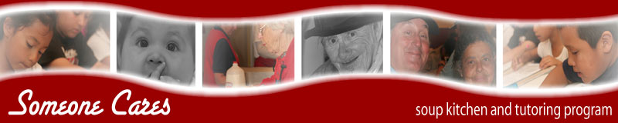
Someone Cares Soup Kitchen
Some Cares Soup Kitchen is a 501(C)(3) nonprofit. Merle Hatleberg, who at the time was working as a Costa Mesa site director for an Orange County seniors program, founded the Someone Cares Soup Kitchen in 1986. Each day, Merle had numerous people coming to the door at her work place who were hungry but didn't qualify as seniors for feeding. Many of these "people" were school-aged children. She was usually able to slip them some food, but there was an unmet need that was deeply troubling to her.
Drawing on her own meager funds, she bought a large pot and made her first .pot of soup. on June 15, 1986. That first day, Merle served about 30 people and the Someone Cares Soup Kitchen was born. From 1986 until 1997, the Soup Kitchen served its meals – setting up in local churches or at the Rea Community Center in Costa Mesa. In 1997, with the help of many local business fundraisers, the Soup Kitchen was able to purchase a building that used to be a Chinese restaurant.
For the past six years, we are proud, along with our dedicated staff and over 150 active volunteers, to have kept the doors open at our location and given our guests a place that they know they are always welcomed.
Someone Cares Needs List
Guest Needs: | Infants and Children: | Kitchen Needs:
Trial or Compact Size:  Shampoo  Conditioner  Toothpaste  Toothbrushes  Razors  Moisturizing Lotion  Deodorant Soap  Hair Brushes/Combs  Feminine Hygiene Products  Sunscreen  Plastic Baggies (small and large) | Infant Formula  Baby Food  Baby Cereal  Diapers (all sizes)  Baby Wipes  Band-aids  Baby Bottles  Bottled Water | Spices (Oregano. Thyme, Cumin, Garlic Powder)  Oil  Pancake Mix and Syrup  Oatmeal  Large #10 Cans of Kidney Beans, Hominy, Garbonzo Beans, Split Peas, White Navy Beans, Black Beans  White Sugar, Brown Sugar, Powdered Sugar  Pasta  Cream of Mushroom Soup  Tomato Products – Stewed Tomato, Spaghetti Sauce, Tomato Paste  9 in. paper plates  6 oz. cups  12 oz. foam bowls



Teen Involvement Conference Code of Conduct

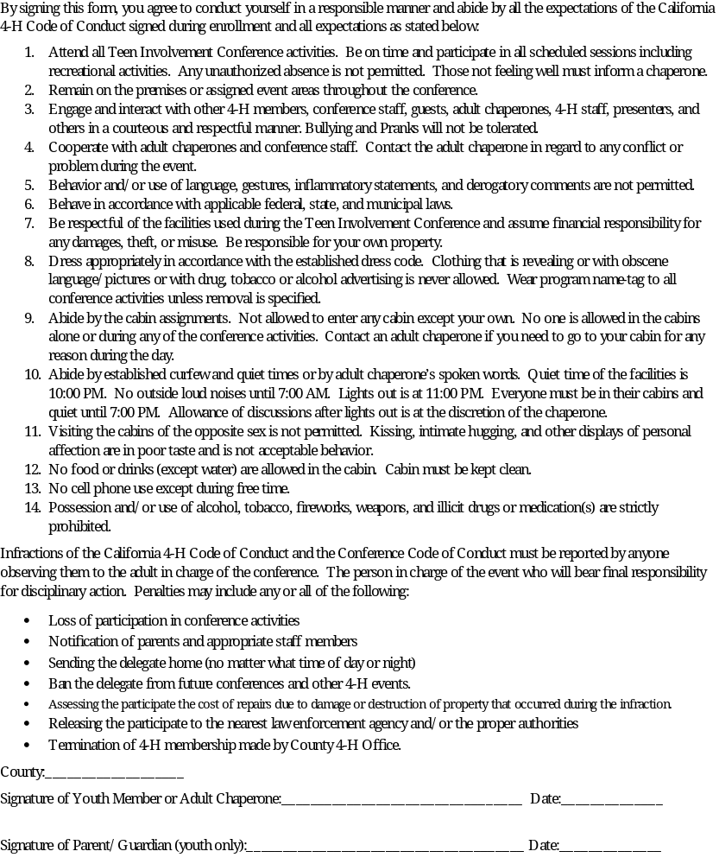
California South Section Teen Council http://ss4h.org

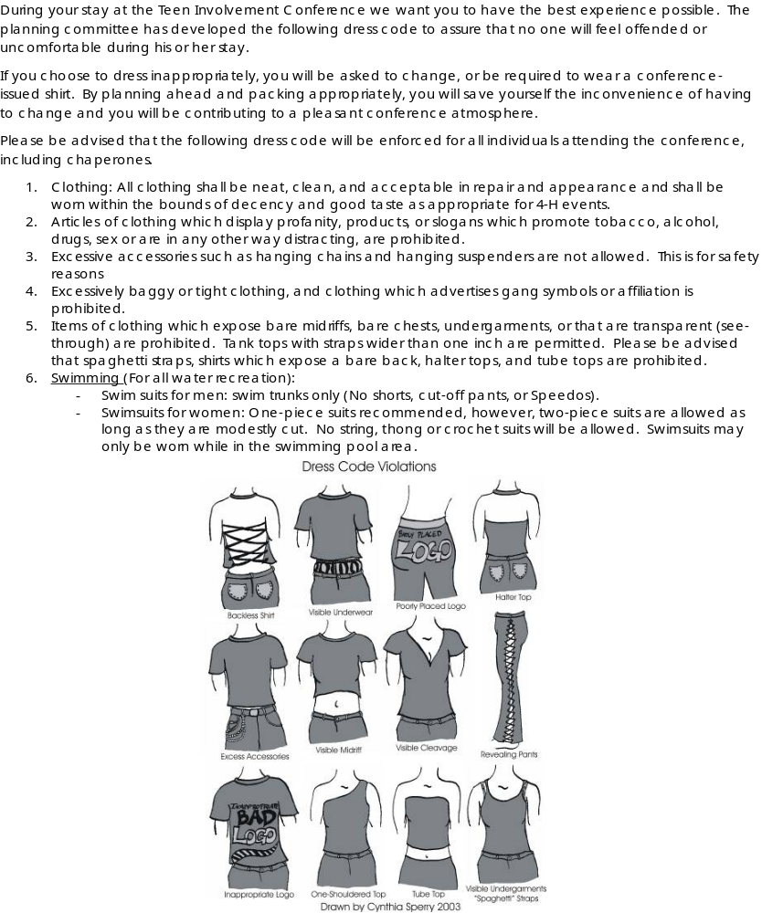
4-H Teen Involvement Conference Dress Code

California South Section Teen Council http://ss4h.org

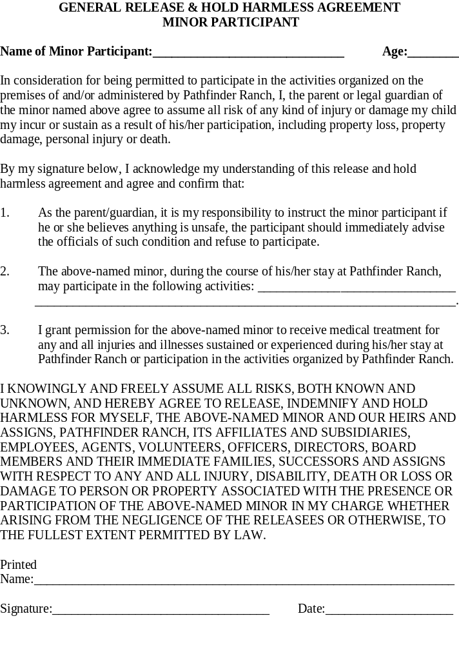

University of California Division of Agriculture and Natural Resources
4-H Youth Development Program
Youth Medical Release Form
This Medical Release Form is authorized for all 4-H Youth Development meetings and activities during the dates specified below:

_________________________________________________ _______________________________________________
First Name Last Name Club/Unit Name

_________________________________________________ ______________________ to _______________________
County and State Dates (From / To)

While my child is attending or traveling to or from this 4-H function, I HEREBY AUTHORIZE THE ADULT 4-H VOLUNTEER LEADER OR 4-H STAFF MEMBER, or in his/her absence or disability, any adult accompanying or assisting him/her, TO CONSENT TO THE FOLLOWING MEDICAL TREATMENT FOR SAID MINOR:

Any x-ray examination, anesthetic, medical or surgical diagnosis or treatment, and hospital care which is deemed advisable by, and is to be rendered under the general or special supervision of any physician and/or surgeon licensed under the provisions of the Medical Practices Act, California Business and Professions Code Section 2000 et seq.; or any x-ray examination, anesthetic, dental or surgical diagnosis or treatment, and hospital care to be rendered by a dentist licensed under the provisions of the Dental Practices Act, California Business and Professions Code Section 1600 et seq.

This authorization is given pursuant to the provisions of Section 25.8 of the Civil Code of California. This authorization shall remain effective until my child completes his/her activities in this program unless sooner revoked in writing. I understand that as a parent/guardian, I will be responsible for the cost of any service or treatment provided not covered by the 4-H Accident/Sickness Insurance Program sponsored by UC Cooperative Extension.

Emergency Contact Information

_____________________________________________________________________________________________
Name Relationship to Youth Identified Above

(______)__________________________________________ (______)__________________________________
Emergency Day Phone (with area code) Emergency Night Phone (with area code)

_____________________________________________________________________________________________
Mailing Address City State Zip

Authorization and Consent and Release
I hereby certify that my child is in good health and can travel to and participate in all functions of the 4-H Youth Development Program as described above. I understand is it my responsibility to keep the information on this form updated (including Health History and parent/guardian status) by contacting the State 4-H Office.

_________________________________________________ _____________
Signature of Parent/Guardian Date

Non-Consent
I do not desire to sign this authorization and understand that this will prohibit my child from receiving any non-life threatening medical attention in the event of illness or accident.

_________________________________________________ _____________
Signature of Parent/Guardian Date

University policy and the State of California Information Practices Act of 1977 require the following information be provided when collecting personal information from you: The information entered on this form is collected under authority of the Smith-Lever Act. Submission of the medical data is voluntary. However, a signature is required on one or the other of the two signature lines above. Failure to provide the medical information and authorization may result in our inability to provide necessary medical treatment. You have the right to review University records containing personal information about you/your child, with certain exceptions as set forth in policy and statute. Copies of University policies pertaining to the collection, use, or release of personal data are available for your examination from the local UCCE County Director, 4-H Youth Development Advisor, 4-H Program Representative, or the State 4-H Director at the California 4-H Youth Development Program, University of California, DANR Building, One Hopkins Road, Davis, CA 95616-8575, (530) 754-8518. Only your own/your child's records are open to your review.

Any known or foreseeable intergovernmental transfer that may be made of the information is as follows: None.

University of California Division of Agriculture and Natural Resources
4-H Youth Development Program
Health History Information
_________________________________________________ ________________________ ______/_______/______
First Name Last Name County Date of Birth

Subject to: | Yes | No | Now Have or Have Had | Yes | No
Colds |  |  | Heart Trouble
Sore Throat |  |  | Asthma
Fainting Spells |  |  | Lung Trouble
Bronchitis |  |  | Sinus Trouble
Convulsions |  |  | Hernia (rupture)
Cramps |  |  | Appendicitis
Allergies |  |  | Has appendix been removed?
Wear corrective lenses? |  |  | Do you walk in your sleep?
Is hearing good?

Date of last Tetanus Vaccination: ____________________________

Please check over-the-counter medications that may be administered:
❑ Tylenol  Ibuprofen  Cough Syrup  Decongestant  Dramamine
❑ Antacid  Polysporin  Hydrocortisone  Other: ________________________________________

Please identify allergies including allergies to food, medications, and drug reactions:

Please list any disability accommodations you will need in order to participate in this program or activity.

Please list all current medications:
Name of Medication | Dosage | Times Taken

Please include any additional remarks and special instructions to better assist emergency service personnel.
Please explain “yes” answers on this page.

The University of California prohibits discrimination or harassment of any person on the basis of race, color, national origin, religion, sex, gender identity, pregnancy (including childbirth, and medical conditions related to pregnancy or childbirth), physical or mental disability, medical condition (cancer-related or genetic characteristics), ancestry, marital status, age, sexual orientation, citizenship, or service in the uniformed services (as defined by the Uniformed Services Employment and Reemployment Rights Act of 1994: service in the uniformed services includes membership, application for membership, performance of service, application for service, or obligation for service in the uniformed services) in any of its programs or activities. University policy also prohibits reprisal or retaliation against any person in any of its programs or activities for making a complaint of discrimination or sexual harassment or for using or participating in the investigation or resolution process of any such complaint. University policy is intended to be consistent with the provisions of applicable State and Federal laws. Inquiries regarding the University’s nondiscrimination policies may be directed to the Affirmative Action/Equal Opportunity Director, University of California, Agriculture and Natural Resources, 1111 Franklin Street, 6th Floor, Oakland, CA 94607, (510) 987-0096.

4-H 1109 (Rev 9/2008)

