Calling all great ideas!!
Do you have a fantastic activity in your County that you would like to share with others.

The purpose of the share fair is to exchange information between clubs and counties.

This can be done as an individual, project, club, or county.

We hope that by sharing activities, events and special projects we will inspire each other to make the best better.

Anything that you do can be displayed. What you think is “normal” might be a unique activity for another county.

IDEAS!!!
- Alameda’s Small Animal Field Day
- Relay for Life
- Tractor Rodeo
- Presentation Day
- The Robot your project made
- The movie you created

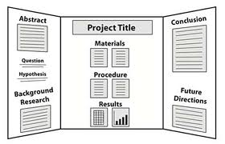
These would consist of a standard 3 fold display board and may include handouts for 4hers to take home for more information.

No one needs to man the display board.

Display boards must stand on their own, with complete information.

