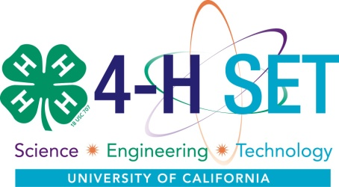
California 4-H SET Checklist Matrix

Program / Activity ______________________________________________________

Components of the 4-H SET Approach | Meets | Partially Meets | Does not meet | Comments
Activities follow the
Experiential Learning Cycle
After the activity, the facilitator leads youth through a period of reflection where the learner shares and processes the experience and applies new learning in authentic situations.
Activities promote
Inquiry Learning using Effective Questioning
Through learning experiences, youth are encouraged to think, explore, question, and make decisions. Youth build understanding through active exploration and questioning.
Provides opportunities to improve
Science, Engineering and Technology Abilities
Engages youth in science, engineering and technology through one or more of the thirty most important science, engineering, and technology processes.
Anchored in a
Positive Youth Development Context
Provides opportunities for youth to develop their 6 C’s: Competence, Confidence, Connections, Character, Caring/Compassion, and Contribution.
Facilitated and delivered with
Adult mentors who partner with youth
Learning experiences led by trained, caring adults and teens who create environments in which they work together as active learners.
Programs offer
Extended Learning Opportunities
Projects offer long-term experiences to significantly increase youth knowledge, skills and attitudes. Experiences are designed for extended frequency and duration that serve to build learning over time.
Programs based on
National Science Education Standards
SET activities delivered through inquiry-based learning focusing on concepts of physical science, life science, earth and space science, science and technology, science in personal and social perspectives, history and nature of science.
Revised January 12, 2011

