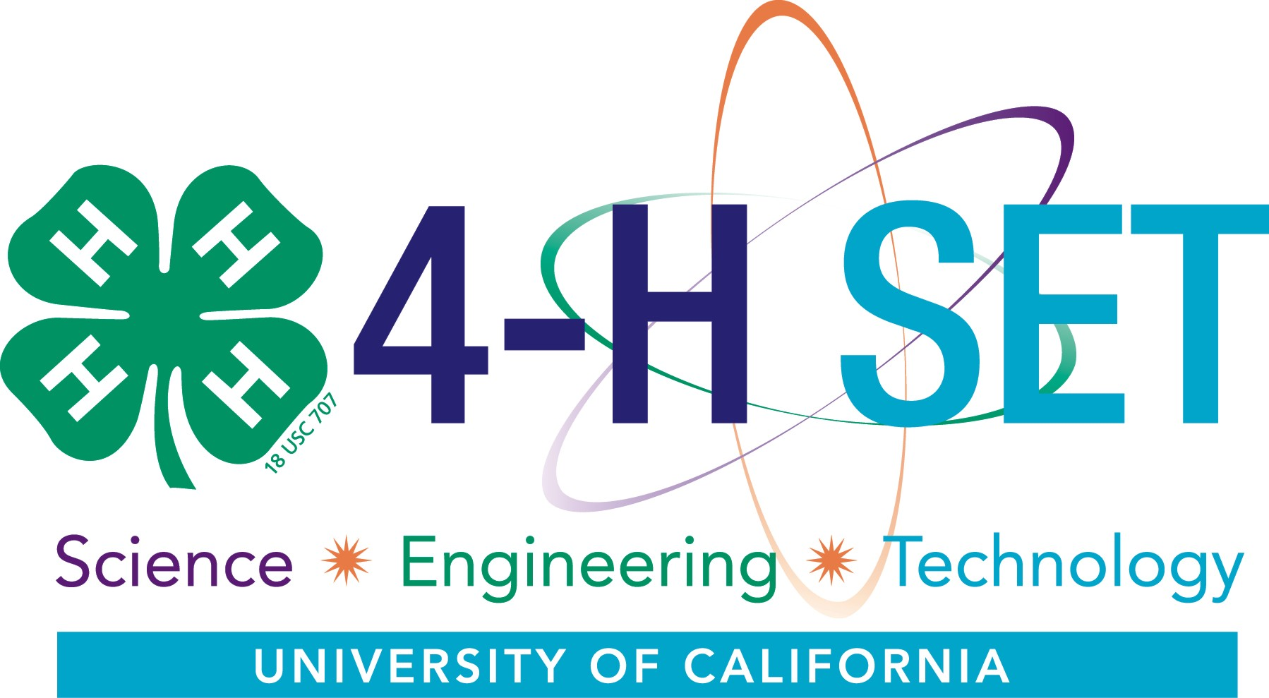

Activity Guide
For
Quick 4-H SET Activities

December 2009
Introduction

4-H science, engineering and technology (SET) activities can enhance your club or project meetings! This guide provides fast and fun science and engineering activities prepared to be SET-Ready. The activities allow youth to have hands-on experiences with a variety of science and engineering topics.

List of Activities

Filters Page 5
Water purification using filters. Ages: 9-19

Senses Page 7
Exploration of the environment through human senses. Ages: 5-19

Polymers Page 9
What happens when youth create polymer chains? Ages: 12-19

Sounds All Around Page 11
Transmit sound waves using rubber bands and craft sticks. Ages: 5-19

Soil Science Page 13
Compare different soil types to assess the texture of each soil sample. Ages: 5-19

Gumdrop Engineering Page 15
Make a structure out of toothpicks and gumdrops that can support weight. Ages: 9-19

Primary Authors
- Steven Worker, CA 4-H Science, Engineering and Technology Coordinator at smworker@ucdavis.edu
CA State 4-H Office, UC Davis, DANR Bldg, One Shields Ave, Davis, CA 95616
- Brenda Bass, UC Davis Linguistics student. Ventra County 4-H Alumnus
- Cassie Markley, UC Davis Ag and Environmental Education undergraduate. Humboldt County 4-H Alumnus.
- Vanessa Zubkousky, UC Davis Environmental and Resource Science undergraduate. Contra Costa County 4-H alumnus and Collegiate 4-H at UC Davis.

4-H SET Leadership Team
- Sharon Junge, Acting State 4-H Director
- Richard Mahacek, Merced County Director and 4-H Youth Development Advisor
- Lynn Schmitt-McQuitty, Santa Cruz & Montery 4-H Youth Development Advisor
- Martin Smith, Specialist, UCD Veterinary Medicine Extension
- Steven Worker, CA 4-H SET Coordinator

Copyright © 2009 The Regents of the University of California.

The University of California prohibits discrimination or harassment of any person on the basis of race, color, national origin, religion, sex, gender identity, pregnancy (including childbirth, and medical conditions related to pregnancy or childbirth), physical or mental disability, medical condition (cancer-related or genetic characteristics), ancestry, marital status, age, sexual orientation, citizenship, or service in the uniformed services (as defined by the Uniformed Services Employment and Reemployment Rights Act of 1994: service in the uniformed services includes membership, application for membership, performance of service, application for service, or obligation for service in the uniformed services) in any of its programs or activities. University policy also prohibits reprisal or retaliation against any person in any of its programs or activities for making a complaint of discrimination or sexual harassment or for using or participating in the investigation or resolution process of any such complaint. University policy is intended to be consistent with the provisions of applicable State and Federal laws. Inquiries regarding the University’s nondiscrimination policies may be directed to the Affirmative Action/Equal Opportunity Director, University of California, Agriculture and Natural Resources, 1111 Franklin Street, 6th Floor, Oakland, CA 94607, (510) 987-0096.

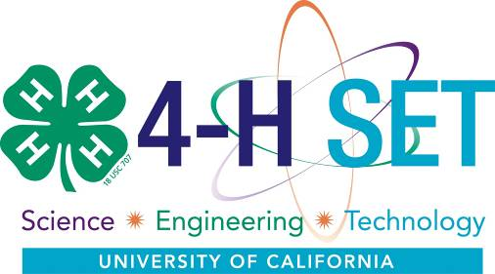
4-H Science, Engineering and Technology (SET) activities and projects combine non-formal education with hands-on, inquiry-based learning in a positive youth development context to engage youth in improving their SET knowledge, skills and abilities. 4-H SET activities and projects combine the strengths of 4-H Youth Development non-formal experiential-based delivery modes and strong youth-adult partnerships to address SET content as defined by the National Science Education Standards.

4-H SET activities will improve SET skills, knowledge and awareness among youth. Through engagement in 4-H SET activities, youth will apply SET learning to all areas of their life, adopting and using new methods of approaching problems. Ultimately, the goal of the 4-H SET Initiative is to increase the number of youth pursuing education and careers in science, engineering and technology.

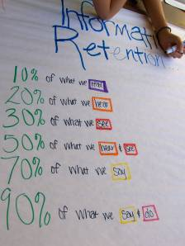
What Does 4-H SET-Ready Mean?

4-H SET-Ready projects and activities are prepared to be delivered consistent with 4-H SET principles. Each activity in this guide is formatted with the information you need to know to lead the activity with groups of youth in a 4-H SET-Ready manner.

- Based on the National Science Education Standards (NRC 1996)
The 4-H Science, Engineering and Technology (SET) Initiative is based on the National Science Education Standards. The Standards present a vision of a scientifically literate populace with the principles:
- Science is for all youth.
- Learning science is an active process.
- Science reflects the intellectual and cultural traditions that characterize the practice of contemporary science.
The Standards outline content youth need to learn about science, which include: physical science, life science, earth and space science, science and technology, science in personal and social perspectives, and history and nature of science.
More information is available at http://www.ca4h.org/SET/documents/CA4HSET-NSES.pdf

- Deliberately Engages Youth in 4-H SET Abilities
Learning science is not about memorization. When youth are encouraged to use science processes to discover knowledge themselves, youth become engaged and motivated to learn science content. Both science content and abilities (processes) are critical to increase science literacy. The 4-H SET program outlines thirty important science processes and refers to them as 4-H SET Abilities. The activities in this activity guide are designed to get 4-H members to use their senses and use the 4-H SET Abilities.
More information is available at http://www.ca4h.org/SET/documents/CA4HSET-Abilities.pdf
- Age-Appropriate
Activities must be developmentally appropriate for participants.
- Promotes Positive Youth Development - Positive youth development occurs from an intentional process that provides youth opportunities to learn new skills, experience independence and develop concern for others in a positive learning environment.
More information is available at http://www.ca4h.org/4hinfo/proginfo/ydelements.asp

- Utilizes Inquiry-Based Learning that includes Effective Questioning Strategies
In inquiry-based learning, youth build understanding through active exploration and questioning. The key to inquiry is that youth seek answers to questions rather than being given answers, which requires those who lead activities to facilitate the learning process and not simply disseminate knowledge. Inquiry-oriented instruction engages youth in the investigative nature of science. This will include:
- active questioning and investigating;
- acquiring new knowledge; and observing and manipulating (mentally or physically) objects, phenomena, and/or nature.
Opening questions help set the stage for the activity. The goal is to have the questions reside with the learner. Questions should promote discussion and interaction and stimulate learner thinking and encourage ideas, speculation, and the formation of hypotheses. Questions should not have a single “right” answer.
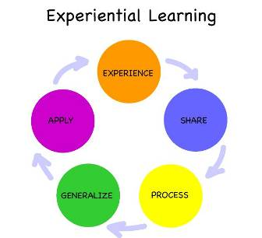
- Follows the Experiential Learning Cycle
Experiential learning (EL) is based on the idea that experience matters in the learning process. Through a concrete learning 1) experience, youth are encouraged to think, explore, question, and make decisions.

To ensure that learning does take place, two other components are required – a period of reflection where the learner shares and processes the experience, and the application of new learning in authentic situations
- Sharing - Get the youth to talk about their experience, share reactions and observations. Discuss feelings generated by the experience. Let the group talk freely about the ideas they generate.
- Processing – Have youth discuss, analyze, reflect, and look at the experience. Discuss how specific problems or issues were addressed.
- Generalizing - Connect the experience with real world examples. Find general trends or common truths in the experience.
- Application - Leaders should encourage and help youth apply what was learned to a new situation. Encourage youth to engage in a new activity and hold a group discussion at the next meeting. Discuss how issues raised can be useful in the future. Help each individual feel a sense of ownership for what was learned.
More information is available at http://www.experientiallearning.ucdavis.edu/

- Assesses Prior Knowledge and Learning Objectives
  - Opening Questions – Use opening questions to gage prior knowledge and experience of youth. Facilitators may need to adapt portions of the activity based on what the learners already know or don’t know.
  - Concept and Term Introduction – Facilitators should ensure youth grasp the key concepts and terms for each activity. To help avoid misconceptions, facilitators should ensure youth understand the concepts and if needed introduce the label of key terms.
Filters!
Concept: Water Quality
Suggested Age: 9-11, 12-14, 15-19

Background Information for the Facilitator
The purpose of this activity is to introduce the topic of water quality and methods of purifying water using filters.
Water is an incredibly important aspect of our daily lives. Every day we drink water, cook with water, bathe in water, and participate in many other activities involving water. Water purification is the process of removing undesirable chemical and biological contaminants from water. Most of the time purification is used to make water safe to drink, but it may also be designed for a variety of other purposes, including meeting the requirements of medical, pharmacology, chemical and industrial applications. Water purification typically uses some type of filter to remove contaminants.

Concepts and Terms
- Water Quality: the physical, chemical and biological agents contained in water. Higher quality of water, safe for humans to drink, typically have few of these particles and organisms
- Purification: process to remove undesirable elements from water
- Filters: a device used to extract impurities from water

National Science Education Standards
- All Grades: History and Nature of Science – Science as a human endeavor
- Grades K-4: Physical Science – Properties of objects and materials
- Grades 5-8: Physical Science – Properties and changes of properties in matter
- Grades 9-12: Science in Personal and Social Perspectives – Natural resources: Water

4-H SET Abilities
Collect Data  Evaluate | Hypothesize  Interpret/Analyze/Reason | Observe  Question

Activity Time: This activity will take approximately 30 minutes.
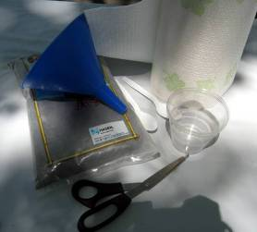
Group Size: Each group should have 3-4 youth each.
Materials
- Large bucket of water with contaminants such as soil, gravel, sand, leaves/grass, soy sauce, and food coloring
Provide each group:
- Container (bucket, jar, milk jug, etc.)
- Scissors
- Paper and plastic cup
Have these filtering supplies available for groups to select:
- Paper products: Paper towel, newspaper, copy paper
- Fabric (e.g. dish cloth, towel, cheese cloth, etc.)
- Rocks or pebbles
- Clean sand (from beach or sand box)
- Leaves
- Other items in the natural environment (non-manmade)
Setup
- Gather the materials for each group.
- Fill the large bucket with water and mix in the contaminants. Ensure enough water is prepared so that each group will have at least 2 cups of dirty water to run through their filter.
- Arrange the filtering supplies in the middle of the room so groups can view them.
- Split youth into groups of 3-4.

Opening Questions
- Why do you think clean water is important?
- What types of things do you think can make water dirty?
- What are some of the ways you’ve seen or heard about water being cleaned?
Experiencing
- Pose the scenario to each group.
Your city has dirty water and needs to get it clean! Your group has been hired to get the clearest water. You will have 10 minutes to design and build something to clean the water. You may select up to three supplies to use to help make the water clean. Two cups of dirty water will be poured into the container.
- Allow each group 10 minutes to discuss and build something to clean the water. Allow groups to select up to three filtering supplies to use.
- After 10 minutes, pour in two cups of dirty water from the large bucket with contaminants.
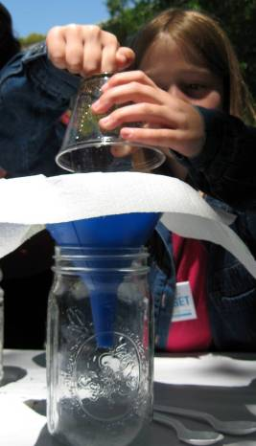
Sharing, Processing and Generalizing
Follow the lines of thinking developed by the youth as they share and compare their thoughts and observations; if necessary, use more targeted questions as prompts to get to particular points.
- How clean does your water look? Compare your water and filters to other groups.
- What changes would you make to your filter to make it even cleaner?
- How do you think you can make the water even cleaner?
- What ideas do you have for removing the food coloring from the water?
- Where have you used or seen other filters? What makes those filters work? Is there anything about those filters that you can apply to this activity?

Concept and Term Introduction
The facilitator needs to ensure that the concepts of water filtration and purification have been introduced or discovered by the youth. The goal is to have the youth develop SET concepts through their exploration and define terms using their own words.

Applying
- Research your local water quality annual report. Visit a local water purification or treatment plant.
- Try cutting apart and opening a water filter at home (e.g. Brita, Amana, Culligan, etc.). What do they use to clean household tap water?

Reference: Monroe County Water Authority (1999). “Kids' Water Fun.” <http://www.mcwa.com/kids.htm#dirty>
Senses
Concept: Exploration of the environment through senses
Suggested Age: 5-8, 9-11, 12-14, 15-19

Background Information for the Facilitator
The purpose of this activity is to engage youth in experimenting with their senses. The youth will use their senses (except their eyes) to hypothesize, interpret, observe, and draw conclusions. Although there are five basic human senses (touch, taste, smell, sight, hearing), most of us rely heavily on sight and touch to interpret the world around us. Our senses help us interpret the world and warn us of dangerous situations. When one sense (sight) is disabled, it causes us to rely more heavily on others.

Concepts and Terms
- Senses: a method plants and animals use to perceive the environment
- Sight: ability of eyes to detect light
- Touch: sensation of feeling on skin and other body parts
- Smell: to perceive odor or scent through the nose
- Hearing: detection of sound vibrations (waves) by the ears
- Taste: determining the flavor or savor of an item by bringing it into contact with the tongue

National Science Education Standards
- All Grades: History and Nature of Science – Science as a human endeavor.
- Grades K-4: Life Science – How organisms obtain information about the environment.
- Grades 5-8: Life Science – Structure and function in living systems.
- Grades 9-12: Life Science – Matter, energy and organization in living systems.

4-H SET Abilities
Collect Data  Evaluate | Hypothesize  Interpret/Analyze/Reason | Observe  Question
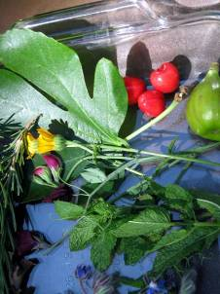
Activity Time: This activity will take approximately 30 minutes.
Group Size: Each group should have 1-10 youth each.
Materials
- Tray
- Cloth to cover tray
- Items with smell and feel (preferably plants/natural items/could be food items, taste, if which to be creative). Examples include leaves, vegetables, fruits, wood, rocks, human-made materials like plastic.
- Blind folds (optional)

Setup
Collect all items and place them in tray under cloth before participants arrive.

Opening Questions
- Ask youth to observe and describe an object near them using their senses.
- Why do you think senses are important?
Experiencing
- While participants are sitting in a circle, have them close their eyes or blindfold them.
- Ask the youth what they sense around them. What do they hear? Smell? Feel?
- Hand out items and ask participants to use their senses to observe the item. Ask them to describe the item using four senses: touch, smell, hearing and taste (if safe to do so).
- Collect the items, remove the blindfolds and ask participants to share their observations.
  - What did you feel? Hear? Smell? Taste?
- After everyone has shared their observations, have them guess which item they were given.
  - Which item do you think you had? Why do you think it was that item?
- Repeat with different items.
Sharing, Processing and Generalizing
Follow the lines of thinking developed by the youth as they share and compare their thoughts and observations; if necessary, use more targeted questions as prompts to get to particular points.
- Share how your senses helped you identify the item.
- What else do you think might have helped you identify the item?
- How do you think your senses could be useful in your environment?
- What are some ways you think you can improve your senses?

Concept and Term Introduction
The facilitator needs to ensure that the concepts of the five common senses: sight, touch, smell, hearing, and taste have been introduced or discovered by the youth. The goal is to have the youth develop SET concepts through their exploration and define terms using their own words.

Applying
- Grades K-3: Ask youth to blindfold themselves at home for five minutes. How well can you walk around your house using your other senses?
- Grades 4-12: At home, find ways your senses help you survive. What senses are helpful to you in identifying dangerous situations? Surviving in your environment? How would this differ if one or more of your senses were removed?

Reference
UC Davis Children’s Garden Program (2009). "No Peeking Activity." < http://childrensgarden.ucdavis.edu/>
Polymers
Concept: Creating polymers using chemical reactions
Suggested Age: 12-14, 15-19

Background Information for the Facilitator
We use plastic in every part of our lives. Due to the extraordinary range of properties, plastics have become an integral part of human society. The chemical equations for plastics are called polymers. There are many types of natural polymers: amber, natural rubber, and biopolymers such as proteins and cellulose; and synthetic polymers: Teflon, vinyl, synthetic rubber, nylon, PVC, silicone, polyethylene, and many more. Polymers may be classified on different attributes such as how they are created, their elasticity, melting point, and other attributes. Polymers degrade due to environmental factors such as heat, light, and chemicals. Putty is a simple type of polymer similar in texture to clay or dough typically used in construction and padding. This activity will engage youth in creating and comparing two types of polymer putties.

Concepts and Terms
- Polymer: a natural or synthetic compound consisting of millions of repeatedly linked units
- Plastic: a type of polymer that may be shaped when soft and then hardened
- Putty: a simple polymer typically used for construction and padding

National Science Education Standards
- All Grades: History and Nature of Science – Science as a human endeavor
- Grades K-4: Physical Science – Properties of objects and materials
- Grades 5-8: Physical Science – Properties and changes of properties in matter
- Grades 9-12: Physical Science – Chemical reactions

4-H SET Abilities
Compare/Contrast  Measure  Evaluate | Hypothesize  Interpret/Analyze/Reason  Plan Investigations | Observe  Question  Test
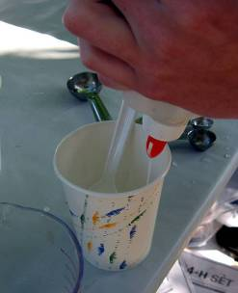
Activity Time: This activity will take approximately 30 minutes.
Group Size: Each group should have 2-3 youth each.
Materials
Each group should have the following:

- Water
- ½ teaspoon of Epsom salt
- 5 tablespoons white glue (e.g. Elmer’s)
- 2 tablespoons liquid starch (e.g. Dial™ STA-FLO in the blue bottle)
- Three cups
- Metal Spoon
- Paper Towels

Setup
- Split youth into pairs or groups of 3.
- Cover the table as this experiment could get a little messy.
- Get the paper towels ready.

Opening Questions
- What are some things you know about plastic?
- What plastic items do you see around you right now?
Experiencing
- Allow youth to observe, feel and explore the ingredients (glue, starch, Epsom salt and water).
- Share your observations of each ingredient.
- What do you think will happen when these ingredients combine?
- Ask pairs to decide who will make Super Putty and who will make Gluep.
Super Putty
  - In one cup, mix ½ teaspoon of Epsom salt and ½ teaspoon of water; stir to dissolve.
  - In another cup, add 1 tablespoon of glue.
  - Add the contents of the two cups together and stir.
Gluep
- Pour 4 tablespoons of white glue into the cup.
- Pour 2 tablespoons of liquid laundry starch into the cup.
- Mix well and then knead with your fingers.
- Encourage youth to experiment with their two types of putty! Having youth come up with questions and design their own experiments is ideal. Here are some sample questions to get discussion started:
- How would you describe each type of putty?
- What do you notice about how they are similar or different?
- Have pairs select something interesting and share it with the other groups.
- If there is additional time, youth can try experimenting with the recipe.
- What happens when more or less of an ingredient is added?
- Can other materials be added to the mixture to change the properties?
- What happens if you use different types of glue?

Sharing, Processing and Generalizing
Follow the lines of thinking developed by the youth as they share and compare their thoughts and observations; if necessary, use more targeted questions as prompts to get to particular points.
- What other substances do you know of that are similar to putty?
- What do you think would be some uses for Super Putty or Gluep?

Concept and Term Introduction
The facilitator needs to ensure that the concept of polymers has been introduced or discovered by the youth. The facilitator can ask the group if they know the term for the substances they created. The goal is to have the youth develop SET concepts through their exploration and define terms using their own words.

Applying
Find out how and where to use putty and complete a project using putty!

Reference: University of Wisconsin-Madison, Wisconsin Initiative for Science Literacy, scifun.org (2008).
“Gluep - Solid or Liquid?” <http://scifun.chem.wisc.edu/HomeExpts/gluep.htm>
Reed, Paul (2005). “Polymers and You.” Cornell University <http://cibt.bio.cornell.edu/programs/archive/0510rtc/Polymers.pdf>
Sounds All Around
Concept: Sound
Suggested Age: 5-8, 9-11, 12-14, 15-19

Background Information for the Facilitator
Sounds are all around us, created by many objects and transmitted through air, liquid and solid matter. The purpose of this activity is to show how sound is transmitted as vibrations and how it’s properties change in relation to other objects. Sound is created when an object vibrates and creates compression wave vibrations in the surrounding air. Sound has several different properties: pitch, volume, quality. Sound can travel through many mediums including air, water, and solid objects.

Concepts and Terms
- Sound: traveling wave of pressure transmitted through air, liquid or solid matter perceived by ear drums
- Sound Compression Wave: vibrations traveling through all forms of matter

National Science Education Standards
- All Grades: History and Nature of Science – Science as a human endeavor
- Grades 5-8: Physical Science – Motions and forces
- Grades 9-12: Physical Science – Motions and forces

4-H SET Abilities
Build/Construct  Evaluate | Measure  Observe | Question  Use Tools

Activity Time: This activity will take approximately 30 minutes.
Group Size: Each group should have 3-4 youth each.
Materials
Each group should have a mixture of the following items. Not each group needs the same objects.

- Containers – cup, cardboard box, tin can, jar, etc.
- 12-24” length of string
- 2-4 varying sized rubber bands
- Tape (any kind)
- Paper and pen
Setup
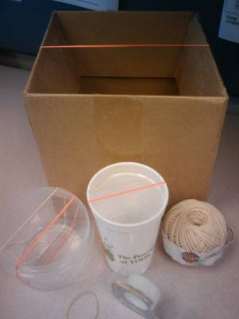
- Gather enough materials for every group.

Opening Questions
- What are some things you know about sound?
- Where do you think sound comes from?

Experiencing
- Ask the group to get into a circle, close their eyes and listen to the sounds around them.
- What can you hear?
- Where were the sounds located?
- What do you think made the sounds? Human or nature?
- Note: If location and time allow, try this a second time in a different location and ask youth to compare the sounds (e.g. first time inside a building and second time outside).
- Split youth into groups of 3 or 4. Provide each group with materials.
- Pose the task: Using the materials provided, make as many different sounds as you can.
- Allow groups 5-10 minutes to experiment and record the number and different ways of making sound.
- With everyone, ask each group to demonstrate:
  - The various sounds they can create
  - The different ways they are making the sounds
  - How the sounds are different from each other

Sharing, Processing and Generalizing
Follow the lines of thinking developed by the youth as they share and compare their thoughts and observations; if necessary, use more targeted questions as prompts to get to particular points.
- What do you think are the sources of the different sounds?
- What do you know about why objects make different sounds?
- What did you observe about the feel and look of the sounds?

Concept and Term Introduction
The facilitator needs to ensure that the concept of sound and sound waves has been introduced or discovered by the youth. The goal is to have the youth develop SET concepts through their exploration and define terms using their own words.

Applying
Observe the sounds other objects make. Do objects vibrate? Can you make music with household items? Ask each youth to find an item and form a 4-H junkyard band!

Reference: University of California 4-H (2001). YES! Youth Experiences in Science: “Children Looking Undercover for
Energy.” <http://anrcatalog.ucdavis.edu/4HResourceSciences/3404A.aspx>
Soil Science
Concept: Earth science and soil properties
Suggested Age Level: 5-8, 9-11, 12-14, 15-19

Background Information for the Facilitator
The purpose of this activity is to explore and compare soils. We build upon soil, various plants and animals live in soil, and soil acts as a filter and storage for water and nutrients. The sizes of the particles in the soil are related to the type of rock it was made from and weather it has been exposed to. Soil textures include sand, silt and clay composition. Sand is the biggest size particle and clay is the smallest size particle. The amount of each type of particle in a soil plays a large role in how the soil performs, including aeration, water movement, resistance to erosion and plant growth. Color in soil is influenced by minerals and organic matter (decomposed plants and animals). The mineral iron gives the soil a red color and organic matter gives soil a dark color. Plants use the minerals, nutrients, and water stored in the soil to grow.

Concepts and Terms
- Soil: the ground composed of a mixture of mineral and organic substances.
- Sand: small loose debris of rocks; largest soil particle
- Silt: earthy matter; smaller particles than sand and larger than clay
- Clay: a natural earthy material consisting of ultra small particles.

National Science Education Standards
- All Grades: History and Nature of Science – Science as a human endeavor
- Grades K-4: Physical Science – Earth Science – Properties of the earth.
- Grades 5-8: Physical Science – Properties and changes of properties in matter
- Grades 9-12: Science in Personal and Social Perspectives – Natural resources

4-H SET Abilities
Collect Data  Evaluate | Hypothesize  Interpret/Analyze/Reason | Observe  Question
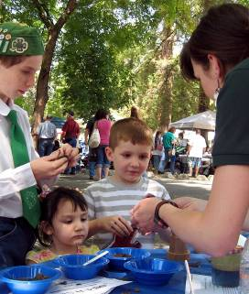
Activity Time: This activity will take approximately 30 minutes.
Group Size: Each group should have 2-10 youth each.
Materials
- Planters, bowls or other container to use as a pot.
- Soil dug out of the ground or potting soil. Acquire multiple soil samples from different areas or depths to compare differences.
- Sand
- Clay
- Water dropper
- Seeds
Setup
- Cover the table as the activity could get messy.
- Put the soils out in separate containers.
- Have an area for members to take a small amount of soil to investigate.

Opening Questions
- Discuss what you know about soil.
- What do you know about how soil is used?

Experiencing
- Allow each youth to touch, smell and look at all of the different types of soil. Encourage youth to report their observations. Here are some sample questions to get discussion started:
- What do you notice about each type of soil? Use your senses.
- What does the soil feel like? Describe how they feel.
- What does each soil smell like? Describe how they smell.
- What does the soil sound like? Describe how they sound.
- What might grow in each type of soil?
- Have youth experiment with small pots (with holes in the bottom) and water, to compare which soil soaks through the fastest and which holds the most water.
- What do you notice about each soil?
- Why might some soils hold more water and others less?
- After youth have compared the various soils, let them select a soil they think will be best to grow a plant.
- What do you know about seeds?
- Which soil do you think will be best for growing this plant? (Varies based on the type of seeds)
- Why do you think that soil will work the best? Would another type work just as well?
Allow each youth to plant a few seeds in their pots.
Sharing, Processing and Generalizing
Follow the lines of thinking developed by the youth as they share and compare their thoughts and observations; if necessary, use more targeted questions as prompts to get to particular points.
- Why do you think soils might smell, feel or look different?
- Why did you select the soil that you did to plant your seed?

Concept and Term Introduction
The facilitator needs to ensure that the concept of soil, sand, silt, clay has been introduced or discovered by the youth. The goal is to have the youth develop SET concepts through their exploration and define terms using their own words.

Applying
- Grades K-3: Find the type of soil you have at home. Is it different or the same from the types in the activity? Would seeds be able to grow in your soil at home? Try it out!
- Grades 4-12: Determine the type of soil you have at home and what types of plants would grow best. Discover the types of additives, such as fertilizer, that would change the properties of the soil.
- Identify the type of soil and tree best suited to your area. Plant a tree and report your tree planting at the 4-H Million Trees Project at http://4hmilliontrees.org/

Reference
USDA Natural Resources Conservation Service (2009). “Soil Education.” < http://soils.usda.gov/education/>
Gumdrop Engineering
Concept: Engineering (design, constructing and testing)
Suggested Age: 5-8, 9-11, 12-14, 15-19

Background Information for the Facilitator
The engineering process is an organized approach to solving problems and developing design solutions that use science, math, and technological knowledge. The engineering process consists of the defining a problem, designing a solution, constructing, testing, and redesigning. This activity demonstrates the process of engineering by having youth design, build, and test a gumdrop structure that will support weight. This activity will get youth to experiment with the stability of different shapes and combining shapes to get the most stable structure.

Concepts and Terms
- Engineering: organized approach to solving problems and developing solutions
- Design: to prepare plans for a structure based on objectives
- Construction: building or assembling a structure based on design plans
- Test: the trial of a structure in meeting design objectives
- Redesign: using test data to revise the plans and construction of a structure

National Science Education Standards
- All Grades: History and Nature of Science – Science as a human endeavor
- Grades 5-8: Physical Science – Changes and forces in matter
- Grades 9-12: Physical Science – Structure and properties of matter & forces

4-H SET Abilities
Build/Construct  Communicate/Demonstrate  Design Solutions  Develop Solutions  Draw/Design | Evaluate  Invent/Implement Solutions  Interpret/Analyze/Reason  Observe  Predict | Problem Solve  Test  Troubleshoot  Use Tools

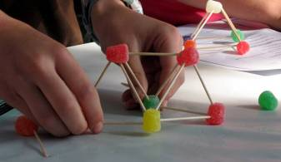
Activity Time: This activity will take approximately 30 minutes.
Group Size: Each group should have 3-4 youth each.
Materials
- One book or other heavy flat object
In addition, each group should get an identical set of supplies:
- Writing utensil and blank paper
- 100 Toothpicks
- Bag of gumdrops
Setup
- Obtain the supplies and put each set into a separate container.
- Split youth into groups of 3-4.

Opening Questions
- Share some of the design features of a tall building you’ve seen.
- What do you know about the engineering process?

Experiencing
Phase I: Identifying and Defining the Problem
- Pose the scenario to each group. Your design firm has been hired to build a tower from the supplies provided that can hold a book for 60 seconds. The tower must be at least 1 toothpick high and a solid structure (all of the pieces must be connected).
- Show the groups the supplies they will be working with.
Phase II: Designing a Potential Solution
- Give each group 5 minutes to discuss and plan a design on paper.
- Allow each group to share their design ideas and reason for thinking their design will work.
  - Share your design. How did you come up with your design?
  - Discuss why you think your design will work.
Note: Do not provide the supplies until each group has shown their plans.
Phase III: Construction
- Distribute toothpicks and gumdrops and give each group 10 minutes to build their tower.
- After 10 minutes, allow each group to discuss their tower.
  - Did you stay with the original design or modify it? Why?
  - Compare your group’s tower with other groups. How does it differ or compare?
  - Which tower do you think will be the most stable?
Phase IV: Testing
- Test each structure with the book to hold its weight for 60 seconds.
  - What other tests could we have conducted?
  - Why do you think some structures were the more effective at holding weight?
  - How could your structure be improved with a redesign?

Sharing, Processing and Generalizing
Follow the lines of thinking developed by the youth as they share and compare their thoughts and observations; if necessary, use more targeted questions as prompts to get to particular points.
- What part of the engineering process was the most difficult? Why?
- How do you think the engineering process might be used in the real world?

Concept and Term Introduction
The facilitator needs to ensure that the concept of engineering: design, construction, testing has been introduced or discovered by the youth. As youth are discussing, highlight these words with the entire group. The goal is to have the youth develop SET concepts through their exploration and define terms using their own words.

Applying
Take photographs of buildings in the community. As a group, identify engineering design strategies.

Reference: Zoom PBS Kids (2002). “Gumdrop Dome.” WGB H Educational Foundation
<http://pbskids.org/zoom/printables/activities/pdfs/gumdropdome.pdf>

